**Collection**:

collection is an API used to store group of objects

collection interface cannot store primitive data type directly, instead it will store in an objects

**Why Collection?**

Collection is a group of objects in a single unit, collection is a container object it is used for

storing multiple homogeneous (sametype) and heterogeneous(different type), unique and duplicate objects without any size limitation.

Entire things (the Diagram) is collection framework and not Interface

**4 ways of stroing values**

1. **Variable** - can store only one value

2. **Class object** - can store multiple fixed number of values of different type

3. **Array object** - can store multiple fixed number of values of same type

4. **Collection object** - can store mulitple object of same and different type without any size

limitations.

**Hierarchy of Collection Framework:**

Conllection framework has mainly and interface knows as Collection interface

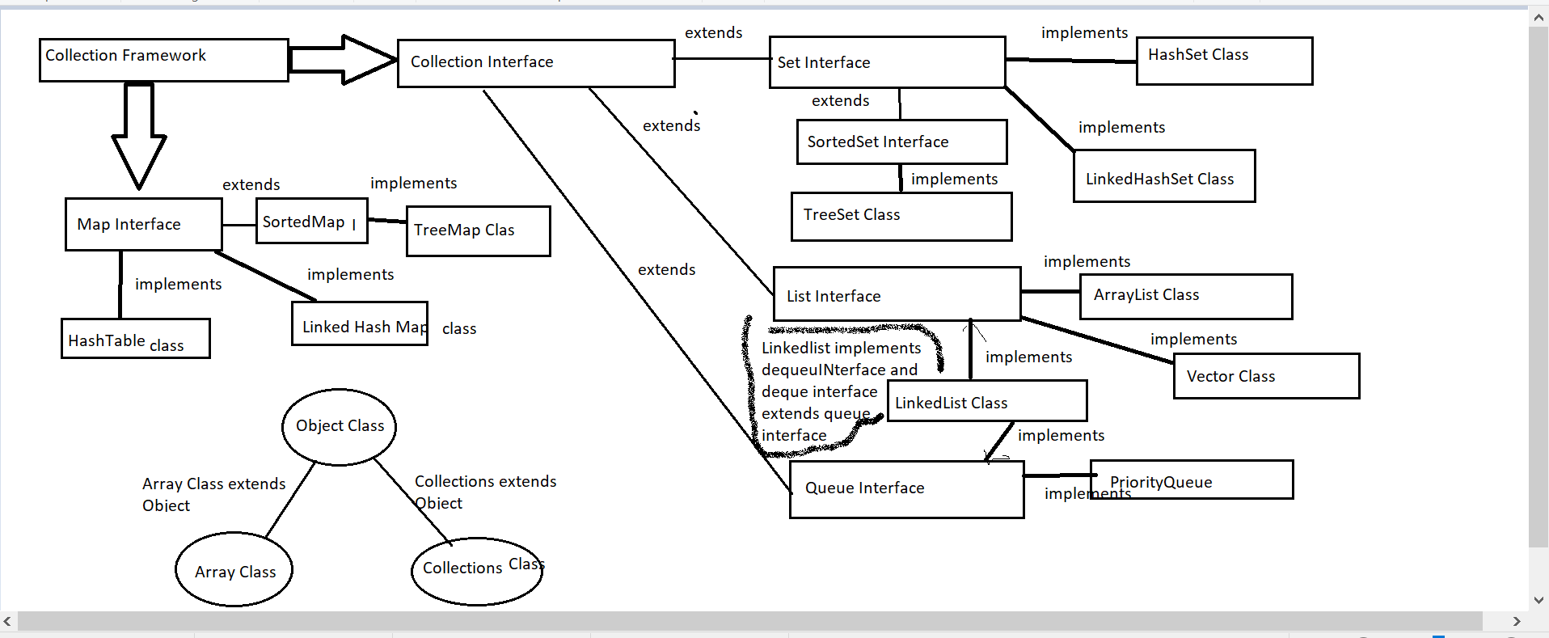

**List Interface**,**Set Interface** and **Queue interface** is the part of **Collection Interface**

**Map** is **not** the part of **collection interface**.Map is **part** of **collection framework**

LIst , Set , Queue Interface **extends** Collection Interface

**List Interace**:

ArrayList Class, LInkedList Class, Vector Class **Implements** the List Interface

**Set Interace**:

HashSet Class, LInkedHashSet Class, TreeSet Class **Implements** the Set Interface

**here TreeSet class do not implement Set interface Directly. IT implements SortedSet Interface and SortedSet Interface extends the Set Interface**

**Queue Interace:**

PriorityQueue Class and LInkedList Class both **implements** Queue Interface

**Map Interface is the part of Collection Framework:**

Hashtable, HashMap , LinkedHashMap, TReeMap Classes **Implements** Map Interface

**here TReeMap class do not impelemnt Map interface Directly. IT implements SortedMap Interface and SortedMap Interface extends the Map Interface**

**Object Class is the super class of all class**

**Array Class** and **Collections Class** extends **Object class**

Here Collection is an Interface and Collections is a Class

**List**:

It is an order based collection or index based collection

example: ArrayList and LinkedList

Contains duplicate elements

provides Dynamic implementation of Array- Size will be increased or decreased automatically

Array[]- fixed size

**Set**:

Set cannot have duplicate elements

doesn’t support insertion order so cannot use typical for loop so have to use iterator

**Queue**:

Store the element in FIFO method

**Map**:

Stores data in key and value pair format

**Iterator**: To iterate the elements from the collection (collection could be list, map or set)

Iterator is an interface which is used to iterate over the collection of list, set and queue type classes.

Iterator interface provides the facility of iterating the elements in forward direction only.

**Why using Collection:**

**Advantages**:

reduces Programming effort

provides inbuilt method and classes which can be used according to usage

high performance

Increases productivity- reduce operational type

Collection is a group of objects in a single unit, collection is a container object it is used for

storing multiple homogeneous and heterogeneous, unique and duplicate objects without

any size limitation.

**Some common methods which is mostly used:**

* add()
* addAll()
* remove()
* removeAll()
* contains()
* containsAll()
* size()
* clear()
* retain()
* retainAll()
* isEmpty();

**Common Exception in collections:**

* NullpointerException- when refernce is pointing null
* ClasscastException - while doing downcasting
* IllegalArgumentException- whenever we pass invalid argument
* IllegalStateException
* UnsupportedOperationException- when collection cannot be modified

**Difference between List/Set/Map Based Classes (Ordering/Access/Key-Value/Duplicate/Thread-Safe)**

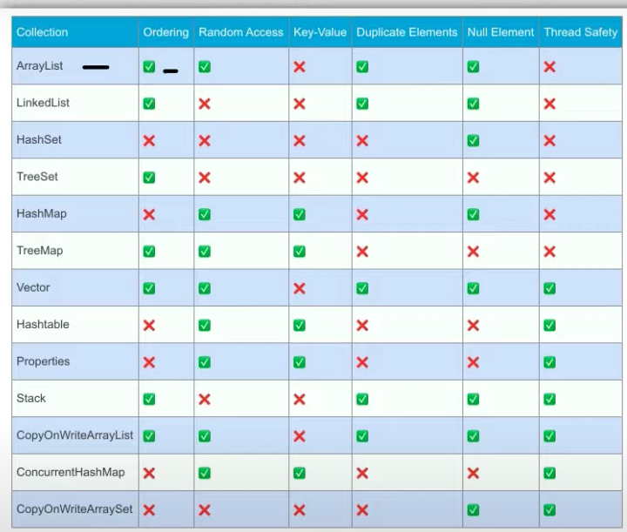

Array list- insertion order and data will be stored in array and random access is possible

|  |  |  |  |  |  |  |
| --- | --- | --- | --- | --- | --- | --- |
| 0th_index | 1st index | 2nd | 3rd | 4th | 5th | 6th |

Now I can access 2nd position index value directly

Can store null value

Thread safety:

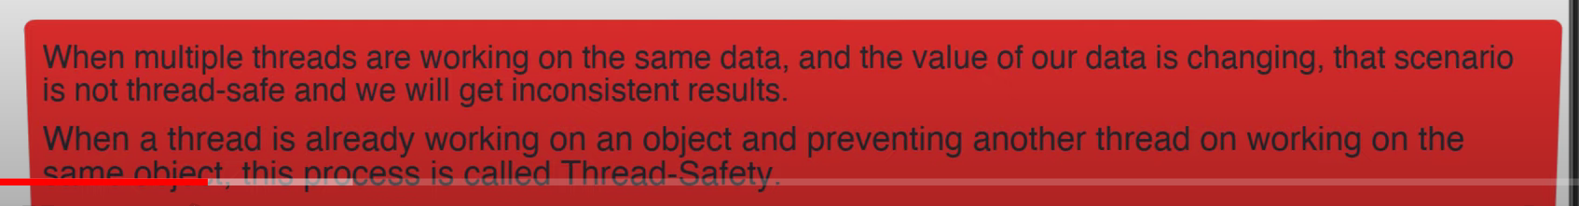

Linked list- is based on nodes so cannot access randomly

|  |  |  |
| --- | --- | --- |
|  | **Array List:** | **LinkedList** |
| **ordering** | Follows insertion order | Follows insertion order |
| **Random access** | Random access of value is possible | **Random access of value is not possible** |
| **Key-value pair** | Key Value pair is not allowed | Key Value pair is not allowed |
| **Duplicate Elements** | Duplicate elements are allowed | Duplicate elements are allowed |
| **Null Elements** | Null values are allowed | Null values are allowed |
| **Thread safe** | Not Thread safe- non synchronized | Not Thread safe- non synchronized |
|  | In ArrayList, manipulation is little bit slower than the LinkedList in Java because a lot of shifting needs to occur if any element is removed from the array list. |  |

|  |  |  |
| --- | --- | --- |
|  | **Array List:** | **CopyOnWriteArrayList** |
| **ordering** | Follows insertion order | Follows insertion order |
| **Random access** | Random access of value is possible | Random access of value is possible |
| **Key-value pair** | Key Value pair is not allowed | Key Value pair is not allowed |
| **Duplicate Elements** | Duplicate elements are allowed | Duplicate elements are allowed |
| **Null Elements** | Null values are allowed | Null values are allowed |
| **Thread safe** | Not Thread safe- non synchronized | **Thread safe- synchronized** |

|  |  |  |
| --- | --- | --- |
|  | **Array List:** | **Vector List**: Before Java 1.2 Vector list was very much used |
| **ordering** | Follows insertion order | Follows insertion order |
| **Random access** | Random access of value is possible | Random access of value is possible |
| **Key-value pair** | Key Value pair is not allowed | Key Value pair is not allowed |
| **Duplicate Elements** | Duplicate elements are allowed | Duplicate elements are allowed |
| **Null Elements** | Null values are allowed | Null values are allowed |
| **Thread safe** | Not Thread safe- non synchronized | **Thread safe- synchronized** |

|  |  |  |
| --- | --- | --- |
|  | **HashSet** | **TreeSet** |
| **ordering** | Do not follows insertion order | **Follows insertion order** |
| **Random access** | Random access of value is not possible | Random access of value is not possible |
| **Key-value pair** | Key value pair is not allowed | Key value pair is not allowed |
| **Duplicate Elements** | Duplicate elements are not allowed | Duplicate elements are not allowed |
| **Null Elements** | Null elements are allowed | **Null elements are not allowed** |
| **Thread safe** | Not Thread safe- non synchronized | Not Thread safe- non synchronized |

|  |  |  |
| --- | --- | --- |
|  | **HashMap** | **TreeMap** |
| **ordering** | Do not follows insertion order | **Follows insertion order** |
| **Random access** | Random access of value is possible | Random access of value is possible |
| **Key-value pair** | Key value pair is allowed | Key value pair is allowed |
| **Duplicate Elements** | Duplicate elements are not allowed | Duplicate elements are not allowed |
| **Null Elements** | Null elements are allowed | **Null elements are not allowed** |
| **Thread safe** | Not Thread safe- non synchronized | Not Thread safe- non synchronized |

|  |  |  |
| --- | --- | --- |
|  | **HashMap** | **HashTable** |
| **ordering** | Do not follows insertion order | Do not follows insertion order |
| **Random access** | Random access of value is possible | Random access of value is possible |
| **Key-value pair** | Key value pair is allowed | Key value pair is allowed |
| **Duplicate Elements** | Duplicate elements are not allowed | Duplicate elements are not allowed |
| **Null Elements** | Null elements are allowed | **Null elements are not allowed** |
| **Thread safe** | Not Thread safe- non synchronized | **Thread safe- synchronized** |

|  |  |  |
| --- | --- | --- |
|  | **HashMap** | **ConcurrentHashMap** |
| **ordering** | Do not follows insertion order | Do not follows insertion order |
| **Random access** | Random access of value is possible | Random access of value is possible |
| **Key-value pair** | Key value pair is allowed | Key value pair is allowed |
| **Duplicate Elements** | Duplicate elements are not allowed | Duplicate elements are not allowed |
| **Null Elements** | Null elements are allowed | **Null elements are not allowed** |
| **Thread safe** | Not Thread safe- non synchronized | **Thread safe- synchronized** |

|  |  |
| --- | --- |
|  | **Stack** |
| **ordering** | follows insertion order- LIFO |
| **Random access** | Random access of value is not possible |
| **Key-value pair** | Key value pair is not allowed |
| **Duplicate Elements** | Duplicate elements not allowed |
| **Null Elements** | Null elements are allowed |
| **Thread safe** | **Thread safe- synchronized** |

|  |  |
| --- | --- |
|  | **Properties-cong files** |
| **ordering** | do not support insertion order |
| **Random access** | Random access of value is possible |
| **Key-value pair** | Key value pair is allowed |
| **Duplicate Elements** | Duplicate elements not allowed |
| **Null Elements** | Null elements are not allowed |
| **Thread safe** | **Thread safe- synchronized** |

|  |  |  |
| --- | --- | --- |
|  | **HashSet** | **copyToWriteArraySet** |
| **ordering** | Do not follows insertion order | Do not follows insertion order |
| **Random access** | Random access of value is not possible | Random access of value is not possible |
| **Key-value pair** | Key value pair is not allowed | Key value pair is not allowed |
| **Duplicate Elements** | Duplicate elements are not allowed | Duplicate elements are not allowed |
| **Null Elements** | Null elements are allowed | Null elements are allowed |
| **Thread safe** | Not Thread safe- non synchronized | **Thread safe- synchronized** |

Priority Queue:

* It orders the elements in First in and First Out manner (FIFO)
* Queue interface is used in Digistra algorithm E.g. Google Maps

# Array vs ArrayList | Virtual Capacity in ArrayList | Generics In ArrayList | Iterate ArrayList

Array : 🡪 called static array because size is fixed

Example:

Int a []=new int [4];

Here we can only have 3 values

|  |  |  |  |
| --- | --- | --- | --- |
| 0th Index | 1st index | 2nd Index | 3rd Index |
| 100 | 200 | 300 | 100 |

a[0]=100; a[1]=200; a[2]=300; a[3]=100;

If we try to get Sytem.out.println(a[4]); // will give ArrayOutOfBoundException as there zie of array a is fixed to 4(here 4 = length of array and 4-1=> index-> index always starts from 0)

Array List:

Array list is dynamic and there is no size limitation.

ArrayList can be created in 3 ways:

**Using default Generics**: (not recommended and Java will give warning)

Here Array List is raw type 🡪 means can add any type of value

Syntax:

ArrayList ar=new ArrayList();

Example:

ArrayList ar=new ArrayList();

ar.add(10);

ar.add(“test”);

ar.add(true);

Here Java will give warning and says reference to arraylist must be parameterized

That means we need to provide the Generics in Array list in such a way that it can add any type of data in list

For this we will use **Object** as parameter

Syntax:

ArrayList<Object> ar=new ArrayList<Object>();

* ArrayList will maintain the insertion order. It means in whatever order you added data in collection will be remain in same order.
* Array List is index based. We can fetch any data using these index
* Negative indexing is not allowed in java
* ArrayList throws ArrayOutOfBoundException if we try to call the index which is not present or greater than index created.
* ArrayList is dynamic in nature i.e. there is no size limitation. Size will automatically add or delete in ArrayList

Virtual Capacity Concept of Array List:

ArrayList<Object> ar=new ArrayList<Object>();

The moment we declare this ArrayList, inside the m/y it will create an array list object in m/y

By default, it will divide into 10 equal parts. Virtual capacity is 10 by default

Virtual capacity does not take nay space as its virtual space

Physical capcity is verified using size() method.

Without adding any data to collection physically, physical capacity will shows a 0

To prove the virtual capacity, we can use the debug and check.

example: Array list physical size without any data is 0 (default value)

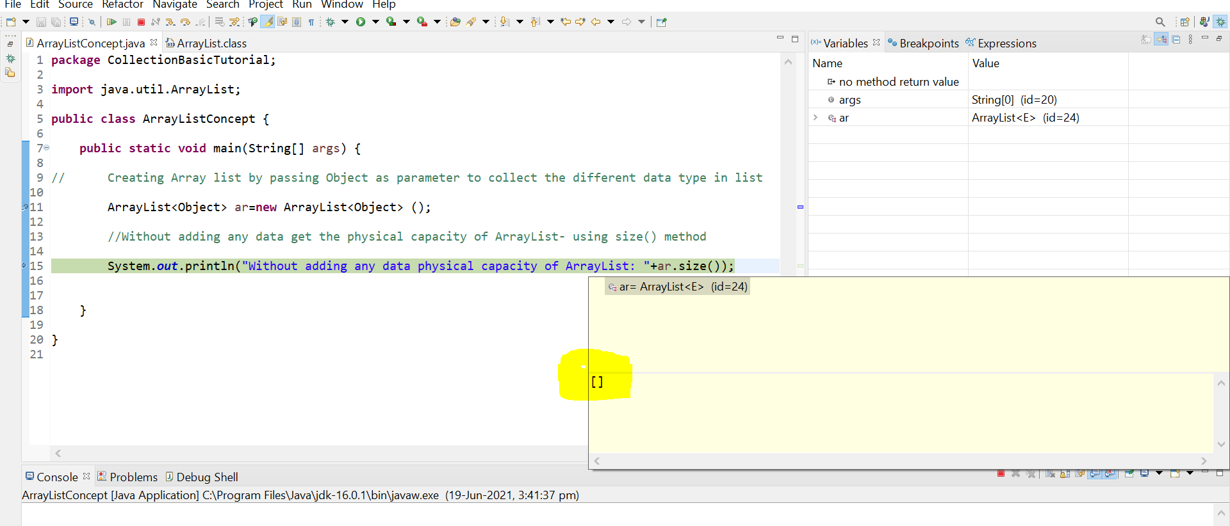

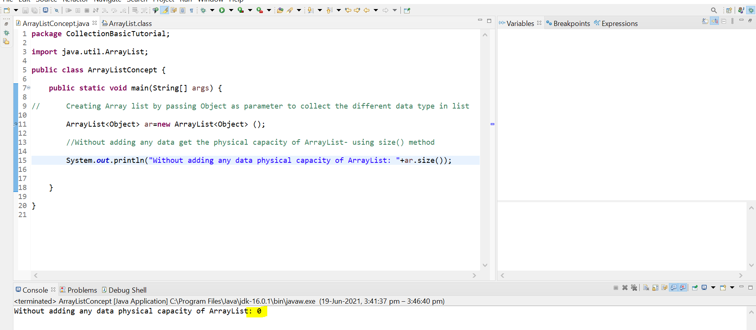

Now add one data in list at 0th index

With the one data added to list virtual capacity is now reduced to 9- (default capacity -1)

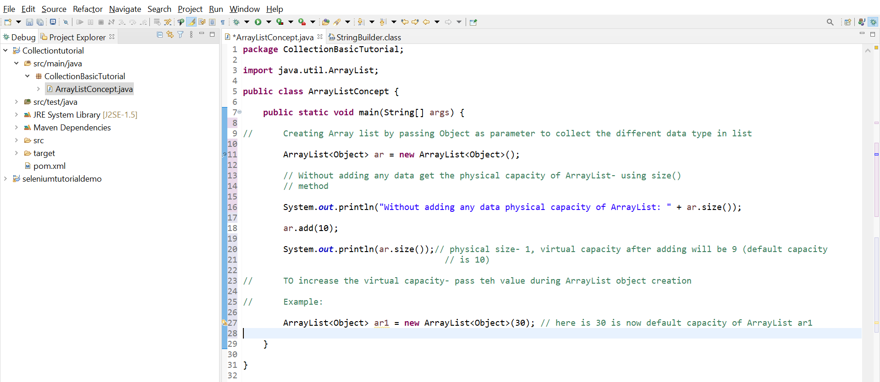

How to change the virtual capacity number?

We can pass the virtual capacity in while creating array list Object as an argument:

ArrayList<Object> ar = new ArrayList<Object>(30); //default capacity is now 30

**Virtual capacity:**

/*  
Virtual capacity of Arraylist is 10 i.e., Internally when the Arraylist object is created then in m/y one arraylist object  
will be created. By default, it will divide into 10 equal parts  
It wont be displayed outside- outside if we try to check size of list it will display as 0 as its physical size  
virtual capcaity doent take any space because it is virtual space  
  
 once we start adding the data to list- virtual capacity will decrease accoridingly  
 EXample: we have added value in 0th index then virtual capcity will be 10-1, if added tw data---> 10-2  
  
We can increase the virtual capacity by passing int capacity as an argument in ArrayList Object  
  
 Arraylist<Object>=new ArrayList<Object>(30); //30 is capacity here now by default  
  
 virtual capacity is also called Initial capacity  
 */  
  
import java.util.ArrayList;  
  
public class VirtualCapacityConcept_4 {  
  
 public static void main(String[] args) {  
  
 ArrayList<Object> ar=new ArrayList<Object>();  
 ar.add(20);//int at 0 index  
 ar.add("String");//String at 1 index  
 ar.add(true);//boolean at 2nd index  
 ar.add(34.5d);//double at 3rd index  
 ar.add(12.5f);//float at 4th index  
 ar.add('D');//char at 5th index-> at this point vitual capacity is- 10-6= 4  
  
 System.out.println(ar);// gives the list of data  
 System.out.println(ar.size());//give the size of list (list is not index)==> index= list.size()-1  
  
// TO increase the virtual capacity- pass teh value during ArrayList object creation  
  
// Example:  
  
 ArrayList<Object> ar1 = new ArrayList<Object>(30); // here is 30 is now default capacity of ArrayList ar1  
 //here now though the physical capcaity shows 0 but virtual capacity is 30  
 System.out.println(ar1.size());//0  
  
 }  
  
}

**ArrayList Iteration:**  
  
/*  
ArrayList can be iterated in below ways:

for loop  
for-each  
lambda with stream() method  
iterator()- using Iterator interface  
  
Iterator Interface  
Iterator is an interface which is used to iterate over the collection of list, set and queue type classes.  
Iterator interface provides the facility of iterating the elements in forward direction only.  
  
Methods in Iterator  
public boolean hasNext() This method returns True when Iterator has more elements  
 This method is used to check whether the collection has element or not  
 If the element is present, then the method returns True else it returns False  
public object next() This method returns the value pointed by the hasNext() method and moves  
 the cursor pointer to next element  
public void remove() This method is used to remove the elements pointed by hasNext()  
 ListIterator Interface  
 • Used to transverse the element in both backward and forward direction, subclass  
 implementation of Iterator interface  
  
• Note: In order to iterate the list in backward direction we need to iterate the list in forward  
 direction  
 Declaration : public Interface ListIterator<E> extends Iterator<E>Core Java part 2  
 Rakesh G 14 | P a g e  
 Methods  
 boolean hasNext() Iterates list in forward direction  
 object next() moves cursor in forward direction  
 boolean hasPrevious() Iterates list in backward direction  
 object previous() moves cursor in backward direction  
*/  
  
import java.util.ArrayList;  
import java.util.Iterator;  
import java.util.ListIterator;  
  
public class ArrayList_Iteration_6 {  
  
 public static void main(String[] args) {  
  
 ArrayList<String> arrayList=new ArrayList<String>();  
 arrayList.add("John");  
 arrayList.add("Neha");  
 arrayList.add("Roma");  
 arrayList.add("Christy");  
 arrayList.add("Jessy");  
 arrayList.add("Rose");  
 arrayList.add("William");  
  
 System.out.println("using for loop:----------------- ");  
  
 for(int a=0;a<arrayList.size();a++){  
 System.out.println(arrayList.get(a));  
 }  
  
 System.out.println("using for each:------------------- ");  
  
 for(String data:arrayList){  
 System.out.println(data);  
 }  
  
 System.out.println("using for lambda with stream() method:---------------- ");  
  
 arrayList.stream().forEach(data-> System.out.println(data));  
  
 System.out.println("Using iterator Interface: ");  
  
 Iterator<String> itr =arrayList.iterator();  
 while(itr.hasNext()){  
 System.out.println(itr.next());  
 }  
  
 System.out.println("Using Listiterator Interface which extends Iterator interface:----------- ");  
// ListIterator is used to iterate in both direction whereas Iterator is used to traverse only in forward direction  
  
 System.out.println("In forward------->");  
 ListIterator<String> lirt=arrayList.listIterator();  
 while (lirt.hasNext()){  
 System.out.println(lirt.next());  
 }  
 System.out.println("In reverse------->");  
 while(lirt.hasPrevious()){  
 System.out.println(lirt.previous());  
 }  
  
  
 }  
  
}

**Ways of creating Array list:**

1. **Using default generics**

public class ArrayListConceptUsingDefaultGenerics_2 {  
  
 public static void main(String[] args) {  
  
 //Array List can be created in 3 ways:  
  
 //default Generics- allows any type of data to add in list  
  
 ArrayList ar=new ArrayList(); //these are raw array list means can add any type of data and not recommended by Java  
 ar.add(456);  
 ar.add("Test");  
  
 //using add with index- we can add data in soecified position by shifting the existing data to next  
 ar.add(1,"Selenium");  
 ar.add(null);  
 System.out.println(ar.size());// 4  
 System.out.println(ar);// [456, Selenium, Test, null]  
  
 //using set with index- we can set the data in specified position by removing the existing data  
 ar.set(3,90);  
 System.out.println(ar.size());// 4  
 System.out.println(ar);// [456, Selenium, Test, 90]  
  
  
 }  
  
}

1. **Using Object as Generics**

public class ArrayListConceptUsingParameters_3 {  
  
 public static void main(String[] args) {  
  
 /* Java recommends to use paramter in arraylist in such a way so that we can add all type data  
 Object is the superclass so adding that as parameter to ArrayList will allow user to add all type of data*/  
  
/*  
• ArrayList will maintain the insertion order. It means in whatever order you added data in collection will be remain in same order.  
• Array List is index based. We can fetch any data using these index  
• Negative indexing is not allowed in java  
• ArrayList throws ArrayOutOfBoundException if we try to call the index which is not present or greater than index created.  
• ArrayList is dynamic in nature i.e. there is no size limitation. Size will automatically add or delete in ArrayList  
*/  
  
  
 ArrayList<Object> ar=new ArrayList<Object>();  
 ar.add(20);//int at 0 index  
 ar.add("String");//String at 1 index  
 ar.add(true);//boolean at 2nd index  
 ar.add(34.5d);//double at 3rd index  
 ar.add(12.5f);//float at 4th index  
 ar.add('D');//char at 5th index  
  
 System.out.println(ar);// gives the list of data  
 System.out.println(ar.size());//give the size of list (list is not index)==> index= list.size()-1  
  
  
 }  
  
}

1. **Using Generics -type safe**

package CollectionInterface;  
/*  
Java recommends to use Generic collection . In real time also we uses the same  
Generic ArrayList is type safe i.e., while createing any arraylist we need to decide what kind of datatype we want to collect using  
list  
  
eX: ArrayList<Integer> ar=new ArrayList<Integer>();  
  
In above ArrayList we caanot store other values other than Integer  
  
ArrayList or any collection class store data as an object. We cannot directly store the primitive data type  
  
To store the primitive data type we need to use Wrapper class and then use it in List  
*/  
  
import java.util.ArrayList;  
  
public class GenericArrayListconcept_5 {  
  
 public static void main(String[] args) {  
  
 ArrayList<Integer> ar = new ArrayList<Integer>(); //can only store integer type data.Integer here is wrapper class  
  
 ar.add(10);  
 ar.add(50);  
 ar.add(60);  
/* ar.add("String");----> throws error  
 ar.add(20.3);--------> throws error  
 */  
 System.out.println(ar.size());  
 System.out.println(ar);  
 System.out.println(ar.isEmpty());  
 System.out.println(ar.get(2));  
  
 }  
  
}

1. **Using other Collection**

/*  
ArrayList can be created in multiple ways:  
  
using default generics- ArrayList ar=new ArrayList();  
using Object generics- ArrayList<Object> ar=new ArrayList<Object>();  
using type safe generic- ArrayList<Integer> ar = new ArrayList<Integer>();  
using other collection- ArrayList<Integer> arrayList=new ArrayList<Integer>(Arrays.asList(20,40,80,100,400,600));  
  
*/  
  
public class ArrayListConceptwithOtherCollection_7 {  
  
 public static void main(String[] args) {  
  
 ArrayList<Integer> arrayList=new ArrayList<Integer>(Arrays.asList(20,40,80,100,400,600));  
  
 System.out.println(arrayList);  
 System.out.println(arrayList.get(2));  
  
 System.out.println("using lambda expression: ");  
  
 arrayList.stream().forEach(a-> System.out.println(a));  
  
 }  
  
}

# ArrayList Methods addAll, clear, clone, contains, indexOf, removeIf, retainAll, subList, toArray

# package CollectionInterface; import java.util.ArrayList; import java.util.Arrays; import java.util.Collections; /* addAll()- two ways to use addAll using collection--->public boolean addAll(java.util.Collection<? extends E> c) returns true if this list added addAll method will add the invoked collection to at end of invoking collection example: collection empId_2 will be added at the end of empId_1 empId_1.addAll(empId_2) ; Using index and Collection ----->public boolean addAll(int index,java.util.Collection<? extends E> c) returns true if this list added addAll method will add the invoked collection to at specified index example: collection empId_2 will be added at specified position in empId_1 empId_1.addAll(2,empId_2) */ // clear()- to clear the list- returns void // add()- adding new values at specified index- null value- ArrayList allows nulls and duplicates // isEmpty()- to verify if list is empty- returns boolean // clone()-> returns a clone of this ArrayList instance.Cloning one list to another list- typecasting si required // contains()- to verify if list contains the particular data. It can be done either by using index or value itself // containsAll()- to verify if the invoking collection contains the any data of invoked collection /* indexOf()- return int--Returns the index of the first occurrence of the specified element in this list, or -1 if this list does not contain the element. More formally, returns the lowest index i such that Objects.equals(o, get(i)), or -1 if there is no such index. */ /* lastIndexOf()-gives index of last element of the specified element. In case of duplicate value it gives the last index of duplicate value Example: we have 3 Jonas in list - at index 1,4,6-- so lastIndexOf("Jonas") will give 6 and if element is not matched its -1 */ // remove(int c): remove the value using index // remove(Object o):(Deprecated)remove th value using object of Wrapper class- example list.remove(new WrapperclassObject(value which wants to be removed)) /* removeAll(Collection c): delete the elements of specified collection from the invoking collection(elements of invoking collection matched with element of invoked collection then those elemnts will be removed from the invoking collection) My understanding: in removeAll function if both collectioni.e., invoked and invoking have same element then that elment will be removed from the invoking collection list */ /* boolean remove = number2.remove(new Integer(30));//deprecated System.out.println("After remove() method which takes object as argument: " + number2); */ // removeIf()- based on condition remove the element from invoking collection.requires lambda expression as condition (var->condition) /* retain():Retains only the elements in this list that are contained in the specified collection. In other words, removes from this list all of its elements that are not contained in the specified collection. My understanding: in removeAll function if both collectioni.e., invoked and invoking have same element then that element will be removed from the invoking collection list Similarly in retainAll function if both collection i.e., invoked and invoking have same element then that element will be retained in the invoking collection list and others will be removed */ // sublist- to get the sublist using from index and to index(in the object of another list pass argument as parentlist.sublist(from,to index)) // toArray()-returns an array containing all of the elements in this list in proper sequence (from first to last element). public class ArrayListMethods_1 { public static void main(String[] args) { ArrayList<Integer> empId_1 = new ArrayList<Integer>(); empId_1.add(201); empId_1.add(202); empId_1.add(203); empId_1.add(204); System.out.println("empId_1: " + empId_1); System.out.println("------------------------------------------"); ArrayList<Integer> empId_2 = new ArrayList<Integer>(); empId_2.add(205); empId_2.add(206); empId_2.add(207); empId_2.add(208); System.out.println("empId_2: " + empId_2); System.out.println("------------------------------------------"); /* addAll()- two ways to use addAll using collection--->public boolean addAll(java.util.Collection<? extends E> c) returns true if this list added addAll method will add the invoked collection to at end of invoking collection example: collection empId_2 will be added at the end of empId_1 empId_1.addAll(empId_2) ; Using index and Collection ----->public boolean addAll(int index,java.util.Collection<? extends E> c) returns true if this list added addAll method will add the invoked collection to at specified index example: collection empId_2 will be added at specified position in empId_1 empId_1.addAll(2,empId_2) */ empId_1.addAll(empId_2); System.out.println("After adding list 2 to list 1: " + empId_1); System.out.println("--------------------------------------"); empId_1.addAll(2, empId_2); // will add the list 2 value at index 2 position and shift the others to next positions System.out.println("After adding list 2 to list 1 with index: " + empId_1); System.out.println("--------------------------------------"); // clear()- to clear the list empId_1.clear(); System.out.println("After invoking clear(): " + empId_1); System.out.println("--------------------------------------"); // add()- adding new values at specified index- null value- ArrayList allows nulls and duplicates empId_1.add(0, null); System.out.println("Allows null values: " + empId_1);//[null] System.out.println("--------------------------------------"); //duplicate value in list empId_1.add(30); empId_1.add(30); empId_1.add(60); System.out.println("Allows duplicate values: " + empId_1); System.out.println("--------------------------------------"); // isEmpty()- to verify if list is empty- returns boolean System.out.println("Checking is list isEmpty using isEmpty() Before invoking clear method: " + empId_1.isEmpty()); System.out.println("--------------------------------------"); empId_1.clear(); System.out.println("After invoking clear(): " + empId_1); System.out.println("--------------------------------------"); System.out.println("Checking is list isEmpty using isEmpty() After invoking clear method: " + empId_1.isEmpty()); System.out.println("--------------------------------------"); // clone()-> returns a clone of this ArrayList instance.Cloning one list to another list- typecasting si required ArrayList<Integer> clonedempId_2 = (ArrayList<Integer>) empId_2.clone(); System.out.println("List after cloning: " + clonedempId_2); System.out.println("--------------------------------------"); // contains()- to verify if list contains the particular data. It can be done either by using index or value itself System.out.println("contain() method: " + clonedempId_2.contains(205));//true System.out.println("contain() method: " + clonedempId_2.contains(2));//false System.out.println("--------------------------------------"); // containsAll()- to verify if the invoking collection contains the any data of invoked collection clonedempId_2.add(70); clonedempId_2.add(90); System.out.println("clonedempId_1 values: " + clonedempId_2); System.out.println("empId_1 values: " + empId_2); System.out.println("containsAll() method : " + clonedempId_2.containsAll(empId_2));//true- as invoking list contains all element as invoked list System.out.println("containsAll() method : " + empId_2.containsAll(clonedempId_2));//false- as invoking list doesnt all element as invoked list System.out.println("--------------------------------------"); /* indexOf()- return int--Returns the index of the first occurrence of the specified element in this list, or -1 if this list does not contain the element. More formally, returns the lowest index i such that Objects.equals(o, get(i)), or -1 if there is no such index. */ ArrayList<String> name = new ArrayList<String>(Arrays.asList("John", "Jonas", "Rehan", "Rose", "Jonas", "Mark", "Jonas")); System.out.println("name list: " + name); System.out.println("Example of unmatched element: " + name.indexOf("Test"));//returns--> -1 as there is no value element in list matched with provided element System.out.println("Example of matched element: " + name.indexOf("Rose"));//returns index of value if matched--2 System.out.println("Example of matched element: " + name.indexOf("Jonas"));//here jonas is duplicate so it will return the 1st matched System.out.println("--------------------------------------"); /* lastIndexOf()-gives index of last element of the specified element. In case of duplicate value it gives the last index of duplicate value Example: we have 3 Jonas in list - at index 1,4,6-- so lastIndexOf("Jonas") will give 6 and if element is not matched its -1 */ System.out.println("verifying lastindex(case sensitive will return -1)): " + name.lastIndexOf("JONAS"));//case sensitive-so returns -1 System.out.println("verifying lastindex: " + name.lastIndexOf("Jonas")); System.out.println("--------------------------------------"); // remove(int c): remove the value using index // remove(Object o):(Deprecated)remove th value using object of Wrapper class- example list.remove(new WrapperclassObject(value which wants to be removed)) /* removeAll(Collection c): delete the elements of specified collection from the invoking collection(elements of invoking collection matched with element of invoked collection then those elemnts will be removed from the invoking collection) My understanding: in removeAll function if both collectioni.e., invoked and invoking have same element then that elment will be removed from the invoking collection list */ ArrayList<Integer> number = new ArrayList<Integer>(Arrays.asList(10, 20, 40, 21, 80, 90, 200, 40, 65, 88, 91)); ArrayList<Integer> number1 = new ArrayList<Integer>(Arrays.asList(10, 30, 50)); ArrayList<Integer> number2 = new ArrayList<Integer>(Arrays.asList(10, 30, 50, 60, 80)); ArrayList<Integer> number3 = new ArrayList<Integer>(Arrays.asList(10, 30, 50, 60)); System.out.println("number list: " + number); System.out.println("number1 list: " + number1); System.out.println("number2 list: " + number2); System.out.println("number3 list: " + number3); number.remove(2); System.out.println("After remove() method which takes index as argument: " + number); /* boolean remove = number2.remove(new Integer(30));//deprecated System.out.println("After remove() method which takes object as argument: " + number2); */ number.removeAll(number1); System.out.println("After removeAll() method which takes Collection as argument: " + number); System.out.println("--------------------------------------"); // removeIf()- based on condition remove the element from invoking collection.requires lambda expression as condition (var->condition) System.out.println("number list: " + number); number.removeIf(a->a%2==1);//used lambda fucntion- where it will check if the element is odd number and if yes, then remove it // number.removeIf(a -> a % 2 == 0);//used lambda fucntion- where it will check if the element is even number and if yes, then remove it System.out.println("removeIf() using lambda: " + number); System.out.println("--------------------------------------"); System.out.println("number2 list: " + number2); number2.removeIf(a->a>30); System.out.println("removeIf() using lambda: " + number2); System.out.println("--------------------------------------"); /* retain():Retains only the elements in this list that are contained in the specified collection. In other words, removes from this list all of its elements that are not contained in the specified collection. My understanding: in removeAll function if both collectioni.e., invoked and invoking have same element then that element will be removed from the invoking collection list Similarly in retainAll function if both collection i.e., invoked and invoking have same element then that element will be retained in the invoking collection list and others will be removed */ ArrayList<Integer> listofNumbers = new ArrayList<Integer>(Arrays.asList(1, 3, 2, 5, 9, 4, 3, 5, 9)); System.out.println("listofNumbers: " + listofNumbers); ArrayList<Integer> listofNumbers_1 = new ArrayList<Integer>(Arrays.asList(33, 21, 44, 4, 8, 56)); System.out.println("listofNumbers_1: " + listofNumbers_1); listofNumbers.retainAll(listofNumbers_1); System.out.println("listofNumbers after retainAll() using two arraylist: " + listofNumbers);//4 is common in both so 4 retained and other removed //Another way:--> using single list- where it will retain only the specified element (multiple element if duplicate) in list listofNumbers.retainAll(Collections.singleton(3)); System.out.println("listofNumbers after retainAll() using single array list: " + listofNumbers); System.out.println("--------------------------------------"); // sublist- to get the sublist using from index and to index(in the object of another list pass argument as parentlist.sublist(from,to index)) ArrayList<Integer> newlist = new ArrayList<Integer>(Arrays.asList(1, 3, 2, 5, 9, 4, 3, 5, 9)); System.out.println("newlist: " + newlist); ArrayList<Integer> sublist_2 = new ArrayList<Integer>(newlist.subList(2, 5)); System.out.println("sublist_2 using newlist: " + sublist_2); // toArray()-returns an array containing all of the elements in this list in proper sequence (from first to last element). Object[] arr = newlist.toArray(); System.out.println("Using toArray(): " + Arrays.toString(arr)); // using loop get all System.out.println("using lambda"); newlist.stream().forEach(a -> System.out.println("Using lambda for toArray(): " + a)); System.out.println("using for each"); for (Object o : arr) { System.out.println("Using for each toArray(): " + o); } } }

# How to [#Synchronize](https://www.youtube.com/hashtag/synchronize) (ThreadSafe) ArrayList in Java | What is CopyOnWriteArrayList class in Java

**package** CollectionInterface;  
  
/*  
Synchonized Array List can be achieved in two ways:  
  
 1. Using Collections.synchronizedList-  
  
 List list = Collections.synchronizedList(new ArrayList());  
  
 in this add, remove method doesnt required any synchronized block but for traversing we require synchronized block  
  
 2. Using CopyOnWriteArrayList class  
  
 in this add, remove, traverse or any method doesnt required any synchronized block*/  
  
**import** java.util.ArrayList;  
**import** java.util.Arrays;  
**import** java.util.Collections;  
**import** java.util.List;  
**import** java.util.concurrent.CopyOnWriteArrayList;  
  
**public class** SynchonizedArrayListConcept_1 {  
  
 **public static void** main(String[] args) {  
  
// Using Collections.synchronizedList-List list = Collections.synchronizedList(new ArrayList());  
  
 List<String> synchronized_1 = Collections.synchronizedList(**new** ArrayList<String>());  
 synchronized_1.add(**"Rani"**);  
 synchronized_1.add(**"Tulsi"**);  
 synchronized_1.add(**"Sarini"**);  
 synchronized_1.add(**"Latha"**);  
  
 //for add/remove no synchronized block is required.for traversing its required  
  
 {  
 **synchronized** (synchronized_1) {  
  
 **for** (String s : synchronized_1) {  
 System.**out**.println(**"Using Collections.synchronizedList: "** + s );  
 }  
  
 }  
 }  
// Using CopyOnWriteArrayList class- thread safe  
  
 CopyOnWriteArrayList<String> synchronized_2=**new** CopyOnWriteArrayList<String>(Arrays.asList(**"Tom"**,**"Rohan"**,**"Josh"**));  
 System.**out**.println(**"Using CopyOnWriteArrayList: "**+synchronized_2);  
  
 //iterate  
 synchronized_2.stream().forEach(a-> System.**out**.println(**"Using CopyOnWriteArrayList and iterating using lambda: "**+synchronized_2));  
  
 //for each:  
 **for** (String s:synchronized_2) {  
 System.**out**.println(**"Using CopyOnWriteArrayList and iterating using foreach: "**+s);  
 }  
  
  
 }  
  
}

**Remove Duplicate Element From ArrayList**

**package** CollectionInterface;  
  
/*Can remove duplicate elemnts from Array list using two ways:  
  
1. Using LinkedHashSet - Set does not allow duplicate elements  
  
Why Linked HAshSet and not HashSet because LinkedHashSet follows insertion order (as Array List) but HashSet does not  
  
Steps:  
 Create an Array list: ArrayList<Generics> arr=new ArrayList<Generics>();  
 Create a LinkedHashSet of same generics and pass the "arr" as argument: LinkedHashSet<Generics> lhas=new LinkedHashSet<Generics>(arr);  
 Create a new ArrayList of same generics and pass the "lhas" as argument: ArrayList<Generics> new_arr=new ArrayList<Generics>(lhas);  
  
System.out.println(new_arr);-> contains only unique value  
  
2. Using stream().distinct().collect(Collectors.toList()): from JDK 8  
  
Steps:  
 Create an Array list: ArrayList<Generics> arr=new ArrayaList<Generics>();  
 Now use stream method and store it in List (List<Generics>)  
 List<Generics> list= arr.stream().distinct().collect(Collectors.toList());  
  
System.out.println(list);-> contains only unique value*/  
  
  
**import** java.util.*;  
**import** java.util.stream.Collectors;  
  
**public class** RemoveDuplicateElementFromArrayList {  
  
 **public static void** main(String[] args) {  
  
// 1. Using LinkedHashSet - Set does not allow duplicate elements  
  
// Create an Array list: ArrayList<Generics> arr=new ArrayList<Generics>();  
 ArrayList<Integer> allnumberlist = **new** ArrayList<Integer>(Arrays.asList(1, 3, 4, 6, 6, 8, 3, 5, 9, 4, 1, 6, 7));  
  
// Create a LinkedHashSet of same generics and pass the "arr" as argument: LinkedHashSet<Generics> lhas=new LinkedHashSet<Generics>(arr);  
 LinkedHashSet<Integer> filteringunique = **new** LinkedHashSet<Integer>(allnumberlist);  
  
// Create a new ArrayList of same generics and pass the "lhas" as argument: ArrayList<Generics> new_arr=new ArrayList<Generics>(lhas);  
 ArrayList<Integer> uniquenumberlistwithoutduplicate = **new** ArrayList<Integer>(filteringunique);  
  
// Iterate using Iterator interface  
 Iterator<Integer> itr = uniquenumberlistwithoutduplicate.iterator();  
 **while** (itr.hasNext()) {  
 System.**out**.println(**"Using LinkedHashSet:--> "** + itr.next());  
 }  
// 2. Using stream().distinct().collect(Collectors.toList()): from JDK 8  
  
// Create an Array list: ArrayList<Generics> arr=new ArrayaList<Generics>();  
 ArrayList<Integer> marksList = **new** ArrayList<Integer>(Arrays.asList(1, 3, 4, 6, 6, 8, 3, 5, 9, 4, 1, 6, 7));  
  
// Now use stream method and store it in List (List<Generics>)  
// List<Generics> list= arr.stream().distinct().collect(Collectors.toList());- Collectors.toList returns List<String> list  
 List<Integer> distinctmark = marksList.stream().distinct().collect(Collectors.toList());  
  
// Iterate using Iterator interface  
 Iterator<Integer> itr1 = distinctmark.iterator();  
 **while** (itr1.hasNext()) {  
 System.**out**.println(**"Using stream().distinct().collect(Collectors.toList()): from JDK 8:--> "** + itr1.next());  
  
  
 }  
  
 }  
}

**Compare two array list**

package CollectionInterface;  
  
/*We can compare array list using below ways:  
1. Use Collections.sort and equals method- first sort the list and then equals  
2. Use removeAll() function to find the additional element- remove all the elements from invoking collection  
 which matches the element of invoked collection  
3. Use removeAll() to find the missing element  
4. Use retainAll() to find the common element- retain all the elements in invoking collection  
 which matches the element of invoked collection  
  
*/  
  
import java.util.ArrayList;  
import java.util.Arrays;  
import java.util.Collections;  
  
public class CompareTwoArrayList {  
  
 public static void main(String[] args) {  
  
  
 ArrayList<Integer> l1 = new ArrayList<Integer>(Arrays.asList(2, 4, 6, 4, 6, 7));  
 ArrayList<Integer> l2 = new ArrayList<Integer>(Arrays.asList(2, 4, 6, 4, 6, 7, 8));  
 ArrayList<Integer> l3 = new ArrayList<Integer>(Arrays.asList(2, 4, 6, 4, 6, 7));  
  
// 1. Use Collections.sort and equals method- first sort the list and then equals  
 Collections.sort(l1);  
 Collections.sort(l2);  
 Collections.sort(l3);  
 System.out.println("l1 matches l2: " + l1.equals(l2));  
 System.out.println("l1 matches l3: " + l1.equals(l3));  
  
// 2. Use removeAll() function to find the additional element  
 l2.removeAll(l1);  
 System.out.println("Additional element: " + l2);//8  
  
// 3. Use removeAll() to find the missing element  
 l1.removeAll(l2);  
 System.out.println("missing element: " + l1);// missing element: []--> means there are no more elements other than matching one on invoking list  
  
// Use retainAll() to find the common element  
 l1.retainAll(l2);  
 System.out.println("common element: " + l1);//[2, 4, 6, 4, 6, 7]  
 }  
}

**LinkedList class Implementation and Hierarchy**

Linked list is more faster than array list

Array list is index based . So if we insert any value in between it requires lots of shifting towards right side- forwarding direction

**Example:**

|  |  |  |  |  |
| --- | --- | --- | --- | --- |
| **10- 0th index** | **20-1st index** | **30-2nd index** | **40-3rd index** | **50-4th index** |

----🡪Stores the data in contagious m/y location

Now if I insert any value in middle say in end index- then internally what happens is there will be once space created in 3rd index and 3rd will shift to fourth and fourth will shift to 5th index and so on.

Head pointing to first node Pointing to null

Single Linked List:

|  |  |  |  |  |  |  |  |
| --- | --- | --- | --- | --- | --- | --- | --- |
| **Data** | **Next**  **pointer** |  | **Data** | **Next**  **pointer** |  | **Data** | **Next**  **pointer** |

Nodes

In single linked list each node contains two fields

* Data
* Pointer

Head is pointing to first node and tail is last node pointing to null

Here pointer is nothing but the link between two nodes (each node pointer pointes to next node)

Traverse only in forward direction

Unlike Array list it does not require to be in contagious m/y location. It can be anywhere in m/y

Unlike Array we cannot fetch the data based on index in Linked list as Linked list does not allow random access. So we need to traverse to access the value

**Linked list creation:**

**package** CollectionInterface;  
  
**public class** sample {  
 Node **head**;  
  
 **class** Node {  
 **int data**;  
 Node **next**;  
  
 Node(**int** data) {  
 **this**.**data** = data;  
 **next** = **null**;  
 }  
  
 }  
  
 **public void** printdata(){  
 Node n=**head**;  
 **while** (n!=**null**){  
 System.**out**.println(n.**data**);  
 n=n.**next**;  
 }  
 }  
  
 **public static void** main(String[] args) {  
 sample obj = **new** sample();  
 Node first = obj.**new** Node(10);  
 obj.**head** = first;  
 Node second = obj.**new** Node(20);  
 first.**next** = second;  
 Node third = obj.**new** Node(30);  
 second.**next** = third;  
 obj.printdata();  
 }  
  
}

**Manipulation is faster in linked list than arraylist**

Unlike ArrayList , Linked list does not requires bit shift.

In Linked list we have pointers, so if ew add or remove any data then automatically pointer will point to next data

but in Array list bit shifting is required if we add or remove the data

# LinkedList various features and methods (Important for Interviews)

Features:

* LinkedList is default class in java
* Internally follows double linked list class
* It can be used as List,stack and queue
* It allows null entry
* Dynamic collection
* Manipulation is faster as no bit shifting requires- easy to remove and delete
* Can contain duplicate elements
* Not a thread safe

Linked list constructors:

* LinkedList()
* LinkedList(Collectection c)

Methods in LinkedList:

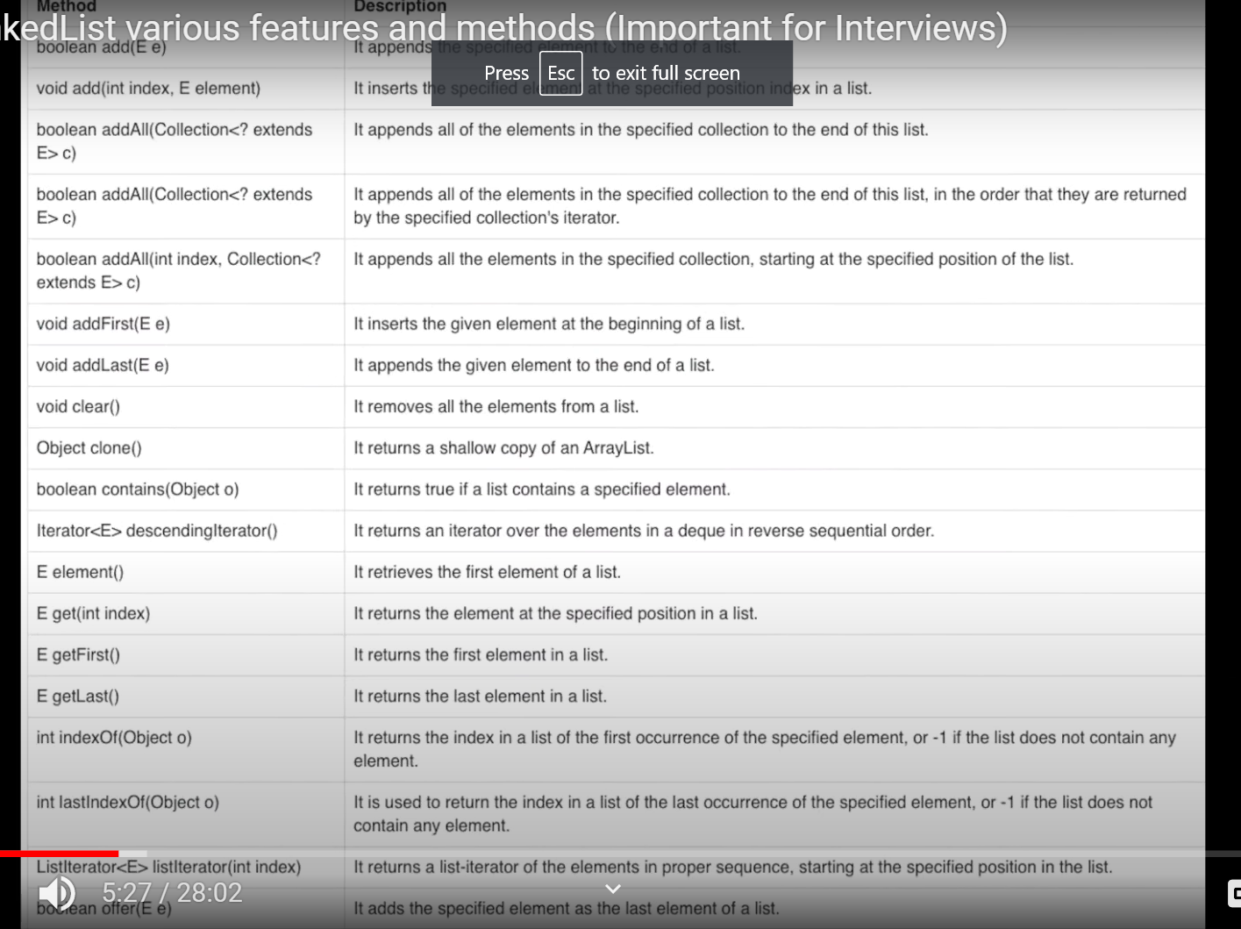

How to declare LinkedList:

LinkedList<Generic> list=new Linked LinkedList<Generic>();//double linked list

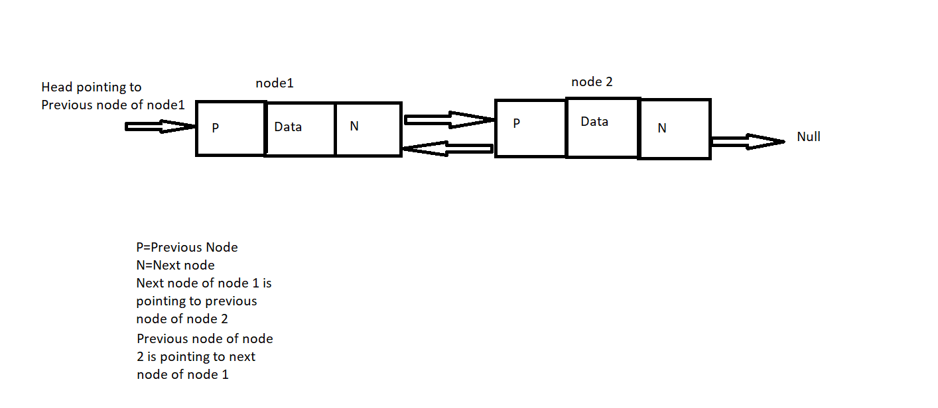

**Proof that random access is not possible in linked list:**   
Random access here means, that you cannot directly access any element in a linked list similar to an array.

In linked list internally you have to traverse each element (link) starting from the head and then you can access that element.  
  
l.get(n);

This method also works the same way in the background. It traverse from the head and then retrieves the nth element

**Code**

**package** CollectionInterface;  
  
/*  
Manipulation is faster in linked list than arraylist  
 Unlike ArrayList , Linked list does not requires bit shift.  
 In Linked list we have pointers, so if ew add or remove any data then automatically pointer will point to next data  
 but in Array list bit shifting is required if we add or remove the data  
  
 LinkedList various features and methods (Important for Interviews)  
  
 Features:  
 • LinkedList is default class in java  
 • Internally follows double linked list class  
 • It can be used as List,stack and queue  
 • It allows null entry  
 • Dynamic collection  
 • Manipulation is faster as no bit shifting requires- easy to remove and delete  
 • Can contain duplicate elements  
 • Not a thread safe  
  
 Linked list constructors:  
 • LinkedList()  
 • LinkedList(Collectection c)  
  
 Methods in LinkedList:  
 void addFirst(Object e) Insert element at first  
 void addLast(Object e) insert element at last  
 Object getFirst() Return first element  
 Object getLast() Return last element  
 Object removeFirst() Returns & Remove first element  
 Object removeLast() Remove last element  
  
 How to declare LinkedList:  
 LinkedList<Generic> list=new Linked LinkedList<Generic>();//double linked list  
  
Proof that random access is not possible in linked list:  
  
Random access here means, that you cannot directly access any element in a linked list similar to an array.  
In linked list internally you have to traverse each element (link) starting from the head and then you can access that element.  
  
l.get(n);  
This method also works the same way in the background. It traverse from the head and then retrieves the nth element  
  
*/  
  
  
**import** java.util.Arrays;  
**import** java.util.Iterator;  
**import** java.util.LinkedList;  
  
**public class** LInkedListConcept_1 {  
  
 **public static void** main(String[] args) {  
  
 LinkedList<String> names=**new** LinkedList<String>();  
 System.**out**.println(**"Size of linked list without adding any data: "**+names.size());  
 System.**out**.println(**"********************************************************"**);  
  
 //adding the data in list  
  
 names.add(**"Jonas"**);  
 names.add(**"Tom"**);  
 names.add(**"Rion"**);  
 names.add(**"Edward"**);  
 names.add(**"Elena"**);  
  
 System.**out**.println(**"Size of linked list without adding any data: "**+names.size());  
 System.**out**.println(**"********************************************************"**);  
  
 //get value using index- get(int index)  
 System.**out**.println(**"getting value using index: "**+names.get(1));  
 System.**out**.println(**"********************************************************"**);  
  
 //getFirst()- gives last value of list  
 System.**out**.println(**"getting value using getFirst(): "**+names.getFirst());  
 System.**out**.println(**"********************************************************"**);  
  
 //getLast()- gives last value of list  
 System.**out**.println(**"getting value using getLast(): "**+names.getLast());  
 System.**out**.println(**"********************************************************"**);  
  
 //addFirst()- add values at 1st node and moves the current first node data to second one  
 names.addFirst(**"Justy"**);  
 System.**out**.println(**"getting value using addFirst(): "**+names);  
 System.**out**.println(**"********************************************************"**);  
  
 //addLast()- add values at last node and moves the last node data to second last one  
 names.addLast(**"Tessa"**);  
 System.**out**.println(**"getting value using addLast(): "**+names);  
 System.**out**.println(**"********************************************************"**);  
  
 System.**out**.println(**"Size of linked list after adding data: "**+names.size());  
 System.**out**.println(**"********************************************************"**);  
  
 //add(int index,datatype element)- adding data to particular index  
 names.add(3,**"Rihana"**);  
 System.**out**.println(**"getting value using add(int index,datatype element): "**+names);  
 System.**out**.println(**"********************************************************"**);  
  
 //Iterate using iterator:  
 Iterator<String> itr=names.iterator();  
 **while** (itr.hasNext()){  
 System.**out**.println(**"Traverse using iterator() method: "**+itr.next());  
 }  
 System.**out**.println(**"********************************************************"**);  
  
 //using lambda expression  
 names.stream().forEach(a-> System.**out**.println(**"Traverse using lambda: "**+a));  
 System.**out**.println(**"********************************************************"**);  
  
 //Removeif using lambda  
 LinkedList<String> names1=**new** LinkedList<String>(Arrays.asList(**"Tom"**,**"nina"**,**"Rihana"**,**"Justy"**));  
 System.**out**.println(**"names1 list : "**+names1);  
 names1.removeIf(a->a.equalsIgnoreCase(**"Justy"**));  
 System.**out**.println(**"names1 list after removeif() : "**+names1);  
 System.**out**.println(**"********************************************************"**);  
  
 //remove(int index)-based on index  
 System.**out**.println(**"names list : "**+names1);  
 System.**out**.println(**"********************************************************"**);  
 names.remove(2);  
 System.**out**.println(**"names list after remove(int index) : "**+names);  
 System.**out**.println(**"********************************************************"**);  
  
 //remove()- removes first element of list  
 names.remove();  
 System.**out**.println(**"names list after remove()-removes first element : "**+names);  
 System.**out**.println(**"********************************************************"**);  
  
 //removeAll- remove all matching value from invoking collection based on invoked collection  
 names.removeAll(names1);  
 System.**out**.println(**"names list after removeall(Collection c) : "**+names);  
 System.**out**.println(**"********************************************************"**);  
  
 //removeFirst()- removing first data from list  
 names.removeFirst();  
 System.**out**.println(**"names list after removeFirst() : "**+names);  
 System.**out**.println(**"********************************************************"**);  
  
 //removeLast- removing last element from list  
 names.removeLast();  
 System.**out**.println(**"names list after removeLast() : "**+names);  
 System.**out**.println(**"********************************************************"**);  
 }  
  
}

# What is Vector || Vector vs ArrayList || Vector vs Array in Java Collections

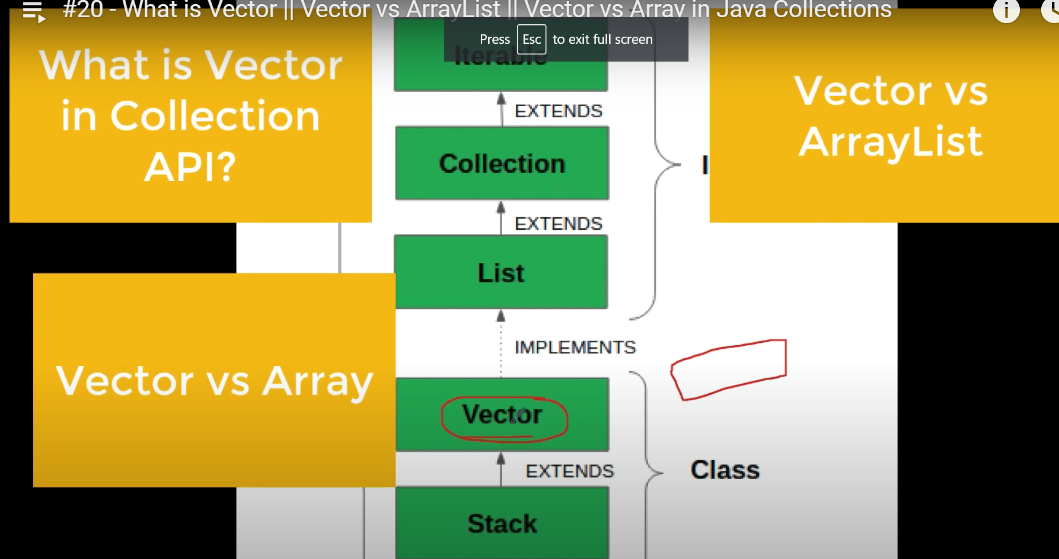

|  |  |
| --- | --- |
| Vector | Array |
| Vector is dynamic in size | Array is static in size |
| Can store only objects | Can store primitive data only |
| Size() method is used to determine size | Length property is used to determine the length |
| Synchronized | Non Synchronized |
| Vector is slower than the array | Array is fast |
| No concept of dimensions, but can be created vector of vectors called 2D vector | Support dimensions |

|  |  |
| --- | --- |
| **Vector** | **ArrayList** |
| Present since the initial version of java(jdk 1.0) | Introduced in java since JDK 1.2 |
| Vector is legacy class of Java | It is part of collection framework |
| initial capacity- 10 | Initial capacity- 10 |
| Can increase double of its size when initial capacity is reached: Old capacity * 2 | Can increase double of its size when initial capacity is reached: (Old capacity * 3/2)+1 |
| Synchronized | Non synchronized |
| Can iterate using iterator and enumerator | Can iterate using iterator |
| Operations are slower | Operations are fast |
| Vector have increment size using which vector size can be increased | ArrayList does not provide increment size |

**Normal Vector Class:**

**package** CollectionInterface;  
  
/*Vector list is same as ArrayList  
Onlymajor difference is VectorList is thread safe  
  
Difference between Array and vector  
  
 Vector Array  
Vector is dynamic in size Array is static in size  
Can store only objects Can store primitive data only  
Size() method is used to determine size Length property is used to determine the length  
Synchronized Non Synchronized  
Vector is slower than the array Array is fast  
No concept of dimensions, but can be created Support dimensions  
vector of vectors called 2D vector  
  
  
Difference between ArrayList and Vector list  
 Vector ArrayList  
Present since the initial version of java(jdk 1.0) Introduced in java since JDK 1.2  
Vector is legacy class of Java It is part of collection framework  
initial capacity- 10 Initial capacity- 10  
Can increase double of its size when initial Can increase double of its size when initial   
capacity is reached: Old capacity * 2 capacity is reached: (Old capacity * 3/2)+1   
Synchronized Non synchronized  
Can iterate using iterator and enumerator Can iterate using iterator  
Operations are slower Operations are fast  
Vector have increment size using ArrayList does not provide increment size  
which vector size can be increased  
  
  
 */  
  
**import** java.util.Enumeration;  
**import** java.util.Iterator;  
**import** java.util.Vector;  
  
**public class** VectorList_1 {  
  
 **public static void** main(String[] args) {  
  
 Vector<String> language=**new** Vector<String>();  
 language.add(**"English"**);  
 language.add(**"Hindi"**);  
 language.add(**"Nepali"**);  
 language.add(**"Marathi"**);  
 language.add(**"Baangla"**);  
 language.add(**"English"**);  
  
 System.**out**.println(language);  
  
 //iterating using Enumerator  
  
 Enumeration<String> e=language.elements();  
 **while** (e.hasMoreElements()){  
 System.**out**.println(**"iterating using Enumerator: "**+e.nextElement());  
 }  
 //iterating using iterator  
  
 Iterator<String> it=language.iterator();  
 **while** (it.hasNext()){  
 System.**out**.println(**"iterating using iterator: "**+it.next());  
 }  
  
 }  
  
}

**2D vector class:**

**package** CollectionInterface;  
  
**import** java.util.Vector;  
  
**public class** Vector2DConcept_1 {  
  
 **public static void** main(String[] args) {  
  
 Vector<String> language=**new** Vector<String>();  
 language.add(**"English"**);  
 language.add(**"Hindi"**);  
 language.add(**"Nepali"**);  
 language.add(**"Marathi"**);  
 language.add(**"Baangla"**);  
 language.add(**"English"**);  
  
 System.**out**.println(**"list of language: "**+language);  
  
 //to implement 2d vector- use non generic vector list  
 Vector nongenericvector=**new** Vector();  
 nongenericvector.add(language);  
  
 //now iterate-   
 **for**(**int** i=0;i<language.size();i++){  
 System.**out**.println( ((Vector)nongenericvector.get(0)).get(i));  
 }  
  
 }  
  
}

**Set Interface:**

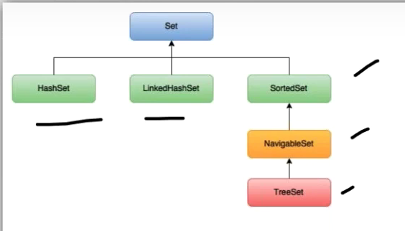

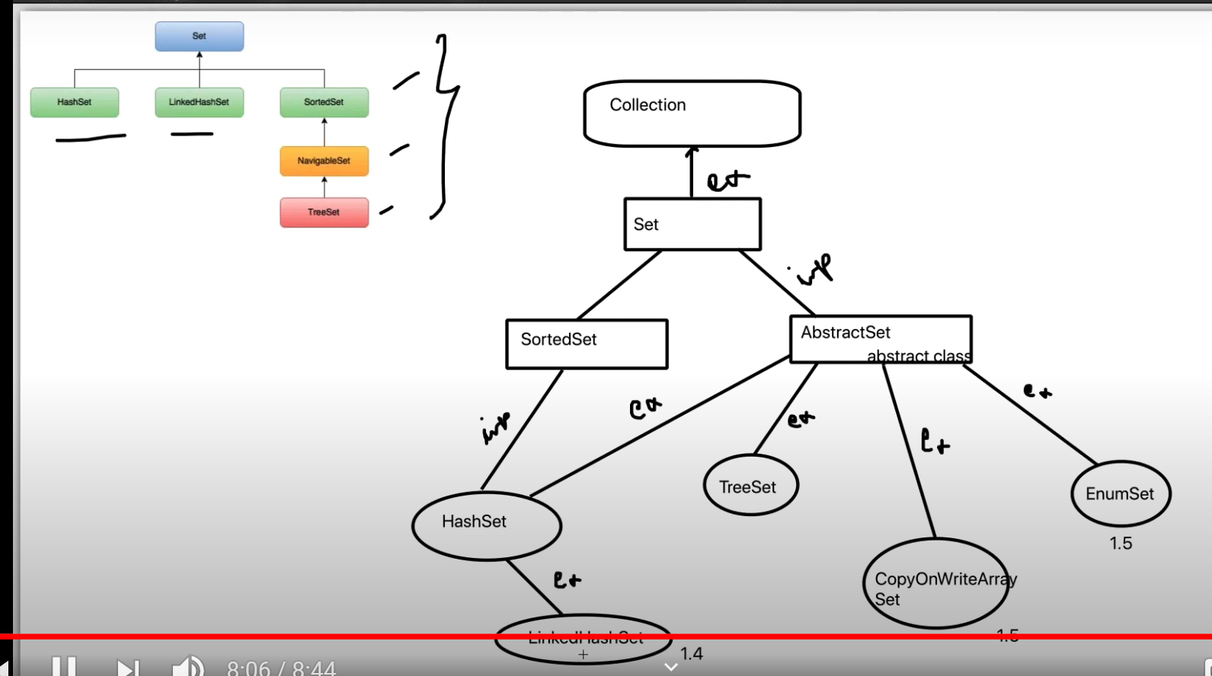

# How HashSet works Internally? Do you know HashSet uses HashMap Internally? (Java Collection)

# Whenever we write

# Hashset<String> s=new Hashset<String>()

# Internally one backing hashmap will be initialized

# Public HashSet(){

# m = new HashMap<>();

# }

**s.add(10);**

**Moment we calls the add method- in below way our data will be added using maps**

**Public Boolean add(E e){**

**M=new HashMap<>(e, Present)- present is value and equals to null**

**}**

# What is HashMap? How to iterate HashMap?

-HashMap class extends AbstractMap class and implementing Map class  
-no insertion order, no index  
-datas in key values pair  
-use put(k,v) method  
-non synchronized  
-Key cannot be duplicate- if we give duplicate value the latest one will be taken  
-One null key is allowed and multiple null values are allowed  
-Note: if we do not have any key and we try to fetch value of unavailable value- then null be given

Hash table and HashMap difference -> hashtable in synchronized and HashMap is non sync  
  
//iterate the map  
  
// 1. Iterator- over the keys: using keySet()  
  
 store the key set into Iterator<Integer> as key is integer so used Integer class Integer class wraps a value of the primitive  
 type int in an object. An object of type Integer contains a single field whose type is int.  
  
 System.out.println("Using keySet()----------->");  
   
 Iterator<Integer> it=student_data.keySet().iterator();  
 while(it.hasNext()){  
 Integer key=it.next(); //storing the key in key variable- here since we have null vkey, so  
 String value= student_data.get(key); //storing value in value variable using map_ref.get(key) method  
 System.out.println("key is: "+key+" and value is "+value);  
 }  
 System.out.println("Using entrySet()-pair---------->");  
  
// 2. Iterator- over the set(pair): using entrySet()  
  
 Iterator<Map.Entry<Integer,String>> itr=student_data.entrySet().iterator();  
  
 while(itr.hasNext()){  
 Map.Entry<Integer,String> data= itr.next();  
 System.out.println("key is: "+data.getKey()+" value is: "+data.getValue());  
 }  
  
 System.out.println("Using lambda---------->");  
   
// 3. Using lambda  
  
 student_data.forEach((k,v)-> System.out.println("key is: "+k+" and value is: "+v));  
  
 }  
  
*/  
  
  
**import** java.rmi.StubNotFoundException;  
**import** java.util.HashMap;  
**import** java.util.Iterator;  
**import** java.util.Map;  
  
**public class** HashMapClass_1 {  
  
 **public static void** main(String[] args) {  
  
 HashMap<Integer,String> student_data=**new** HashMap<Integer,String>();  
  
 student_data.put(20,**"Enrique"**);  
 student_data.put(23,**"Avril"**);  
 student_data.put(13,**"Justin"**);  
 student_data.put(33,**"Rihana"**);  
 student_data.put(**null**,**"Adele"**);  
 student_data.put(**null**,**"Charlie"**);  
 student_data.put(60,**"Shawn"**);  
 student_data.put(22,**"Celine"**);  
  
 System.**out**.println(student_data);//{null=Charlie, 33=Rihana, 20=Enrique, 22=Celine, 23=Avril, 60=Shawn, 13=Justin}  
  
 System.**out**.println(student_data.get(**null**));//charlie  
 student_data.put(80,**"Bruno"**);  
 System.**out**.println(student_data.values());  
  
 //iterate the map  
  
// 1. Iterator- over the keys: using keySet()  
/*store the key set into Iterator<Integer> as key is integer so used Integer class Integer class wraps a value of the primitive  
type int in an object. An object of type Integer contains a single field whose type is int.*/  
  
 System.**out**.println(**"Using keySet()----------->"**);  
 Iterator<Integer> it=student_data.keySet().iterator();  
 **while**(it.hasNext()){  
 Integer key=it.next(); //storing the key in key variable- here since we have null vkey, so  
 String value= student_data.get(key); //storing value in value variable using map_ref.get(key) method  
 System.**out**.println(**"key is: "**+key+**" and value is "**+value);  
 }  
 System.**out**.println(**"Using entrySet()-pair---------->"**);  
  
// 2. Iterator- over the set(pair): using entrySet()  
 Iterator<Map.Entry<Integer,String>> itr=student_data.entrySet().iterator();  
  
 **while**(itr.hasNext()){  
 Map.Entry<Integer,String> data= itr.next();  
 System.**out**.println(**"key is: "**+data.getKey()+**" value is: "**+data.getValue());  
 }  
  
 System.**out**.println(**"Using lambda---------->"**);  
// 3. Using lambda  
 student_data.forEach((k,v)-> System.**out**.println(**"key is: "**+k+**" and value is: "**+v));  
  
 }  
  
}

**Why null value throws error though the nulls are allowed in few Collection Interface:**

Adding a null to the hash set is **not** the problem, that part works just fine. Your NPE comes later, when you try and unbox your values into a primitive int

When the null value is encountered, the JVM attempts to unbox it into an the int primitive, which leads to an NPE. You should change your code to avoid this:

Example:

hashSet.add(2);

hashSet.add(5);

What is really happening is:

hashSet.add(new Integer(2));

hashSet.add(new Integer(5));

Adding a null to the hash set is **not** the problem, that part works just fine. Your NPE comes later, when you try and unbox your values into a primitive int:

while(it.hasNext()){

int i = it.next();

System.out.print(i+" ");

}

When the null value is encountered, the JVM attempts to unbox it into an the int primitive, which leads to an NPE. You should change your code to avoid this:

while(it.hasNext()){

final Integer i = it.next();

System.out.print(i+" ");

}

**Important:**

# How HashMap works internally || Popular java interview question on collection (HashMap)

**Key is determined using hashcode**

**Hashcode of key null is always 0- will always stored at 0 index**

**When there is multiple k,v pair ispresent in same index, then it will from a linked list.. that’s called collision**

**When no. of nodes reaches to threshold (i.e 8), then from 9th node onwards balanced binary tree will be formed from jdk 1.8**

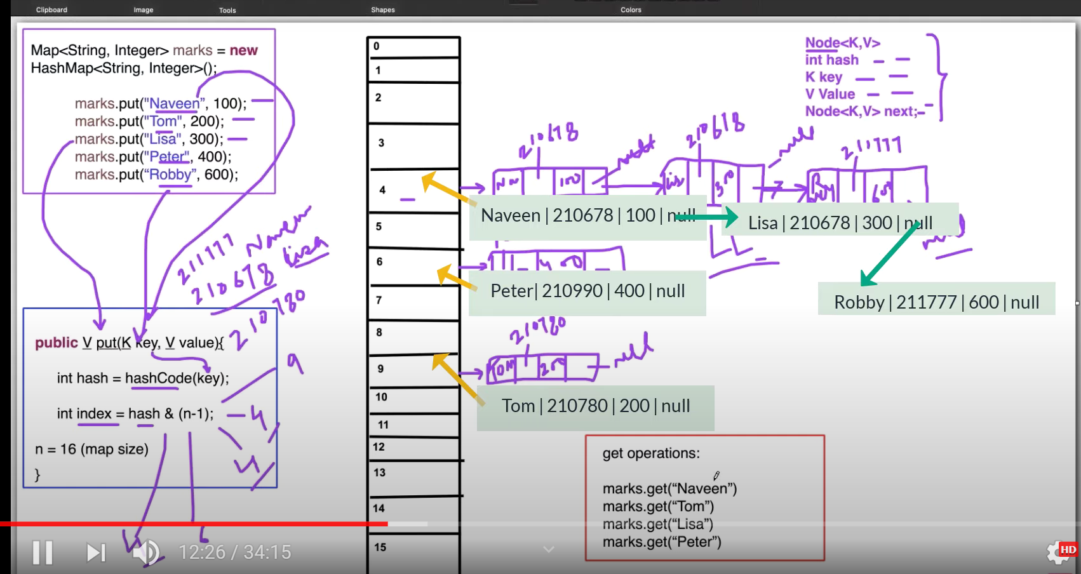

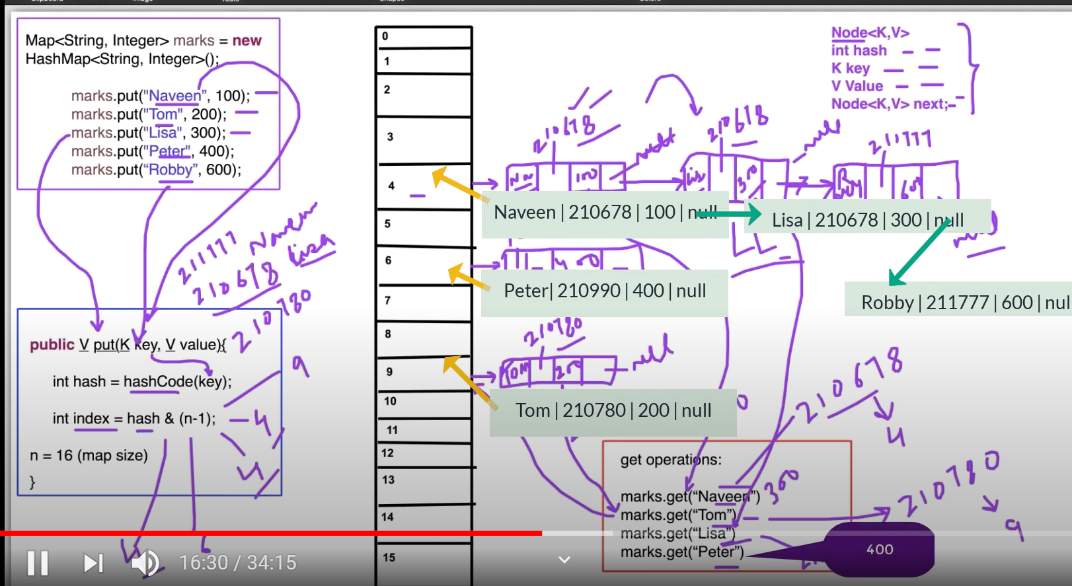

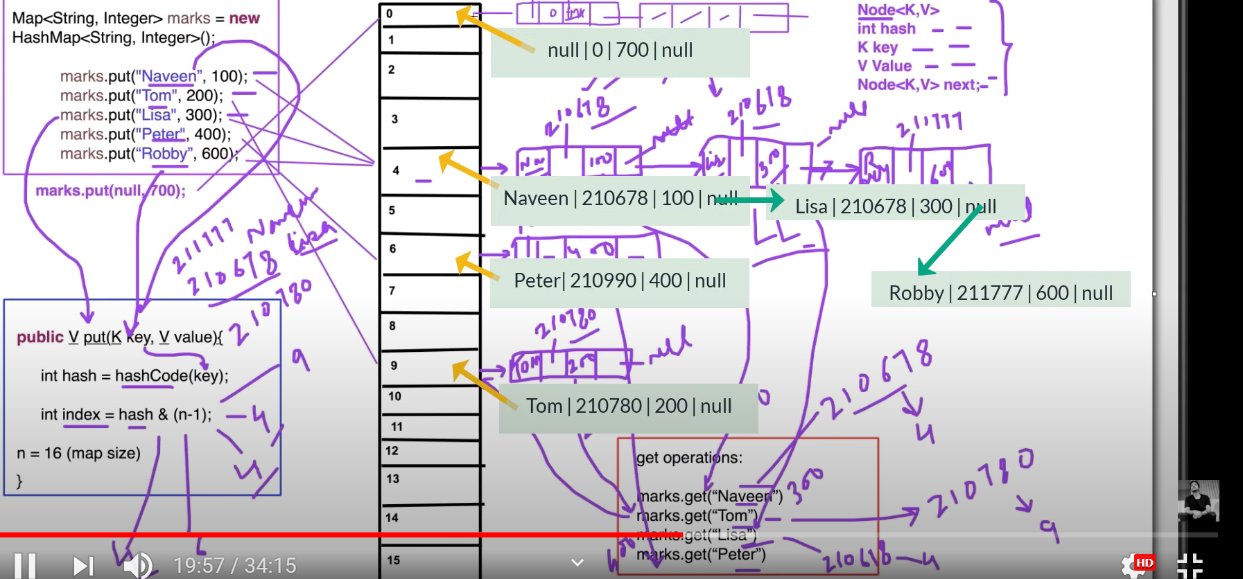

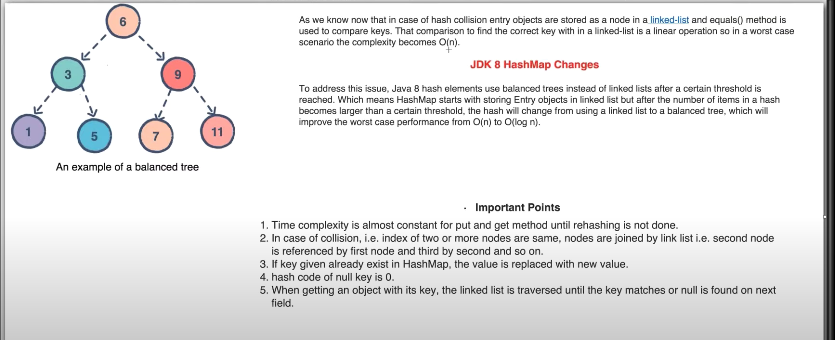

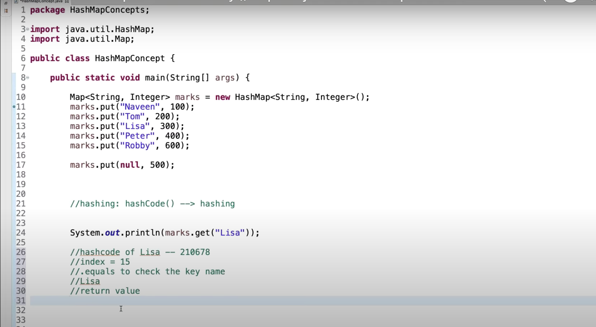

# Different ways of creating HashMap in Java

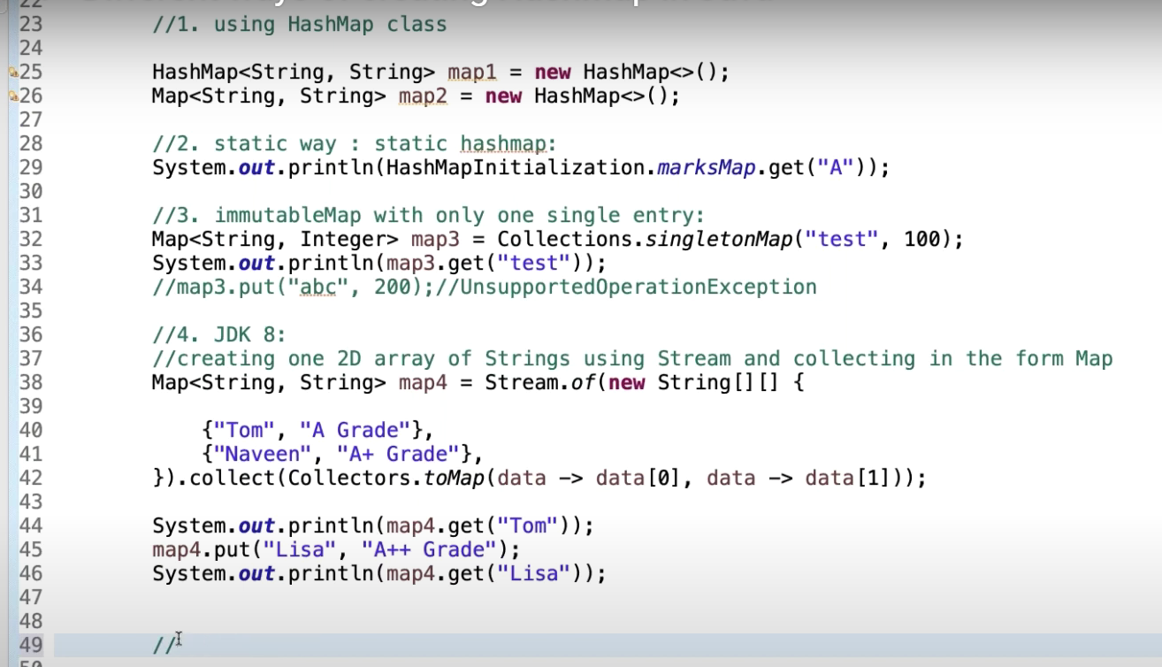

**ConcurrentHashMap vs Synchronized Map:**

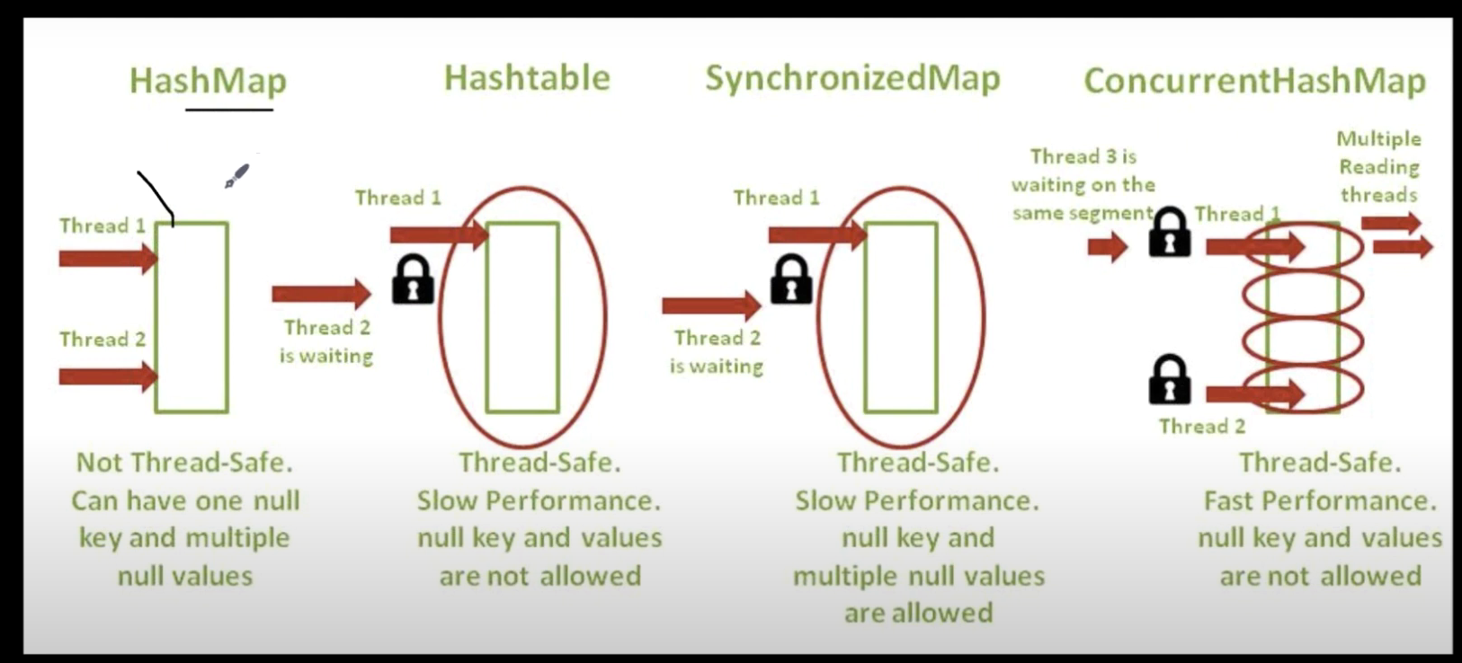

**TreeMap:**

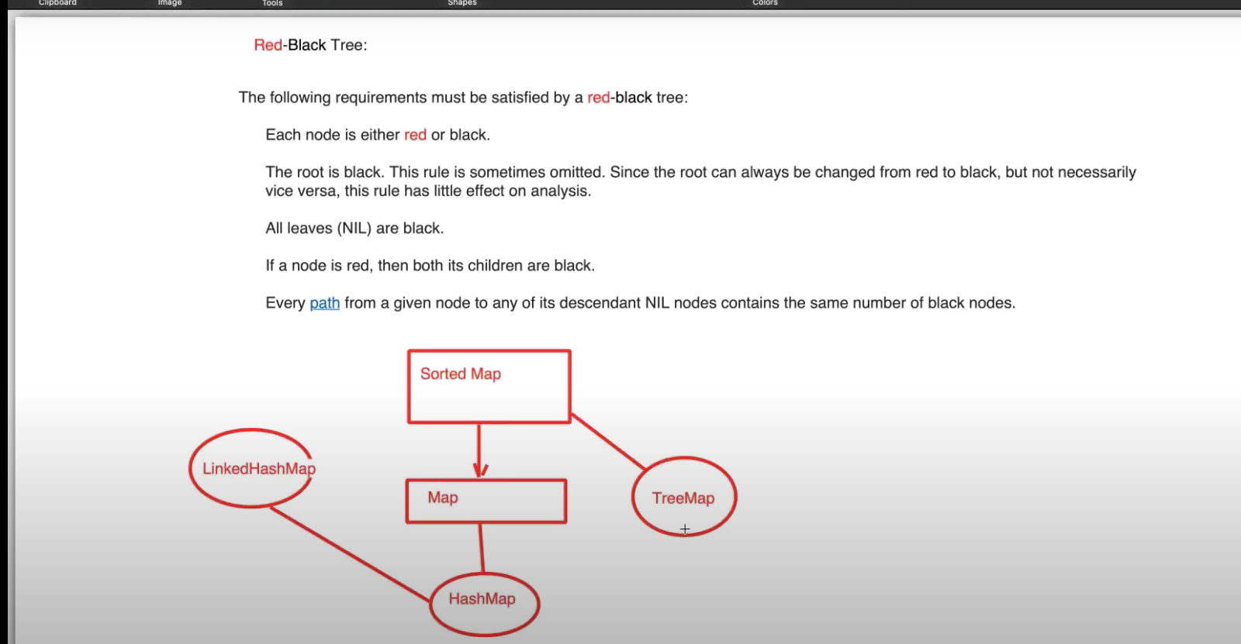

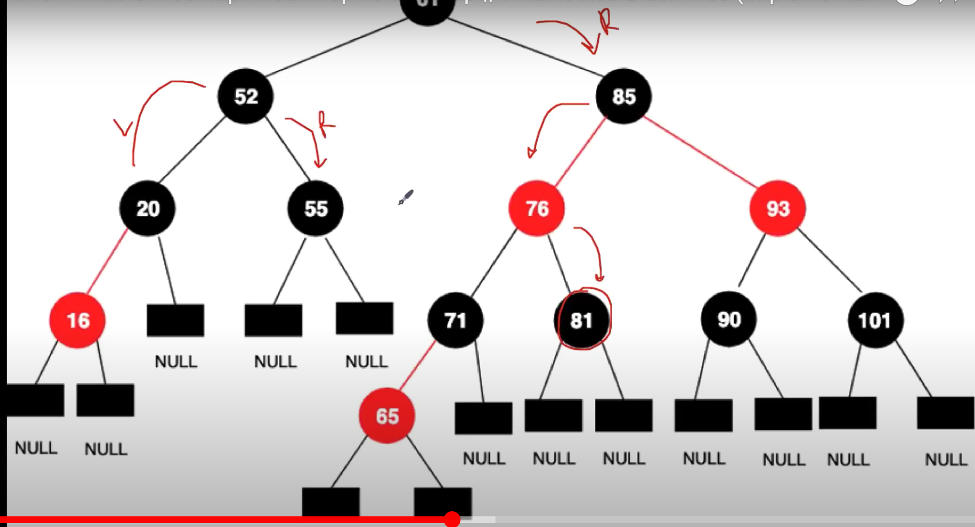

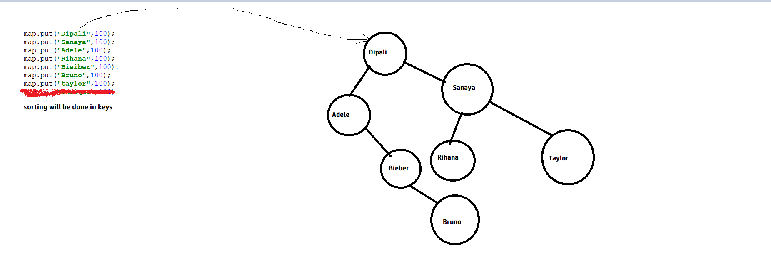

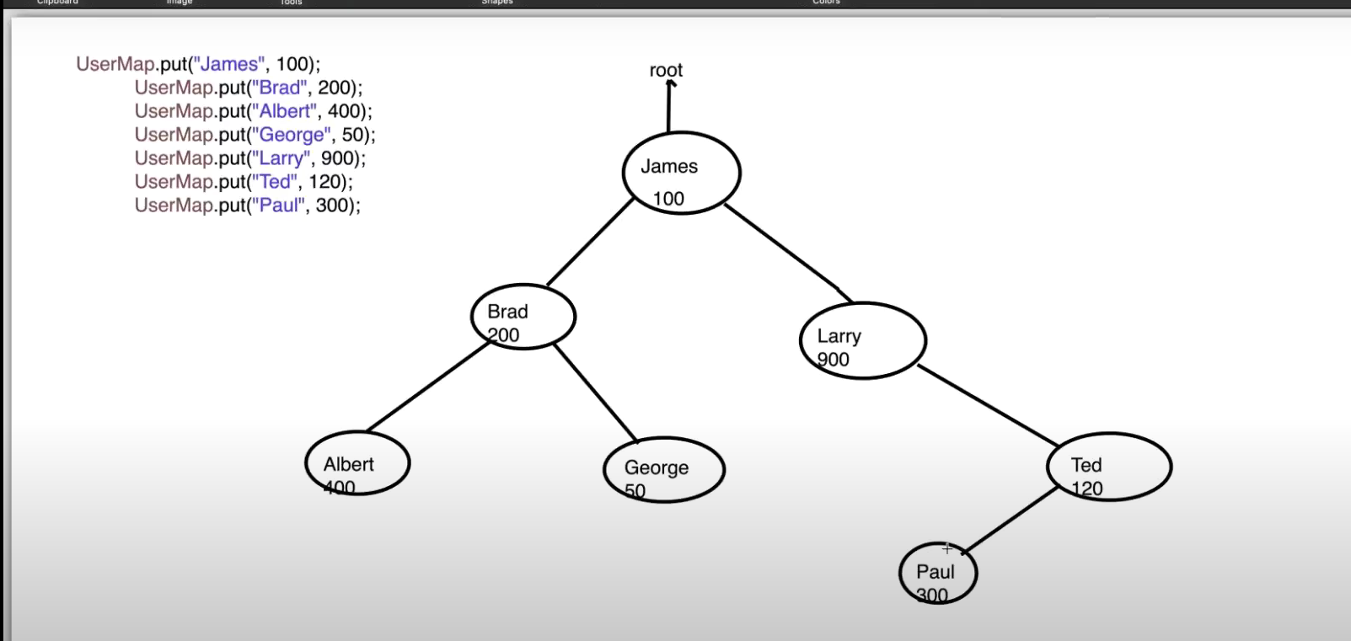

# How HashTable works Internally? HashTable vs HashMap in Java

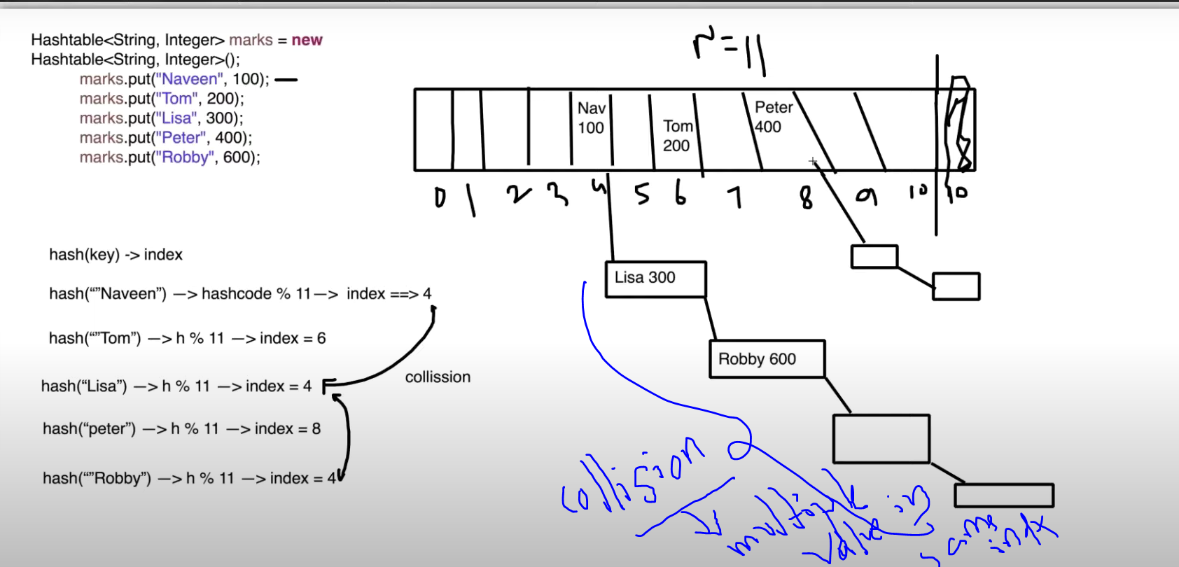

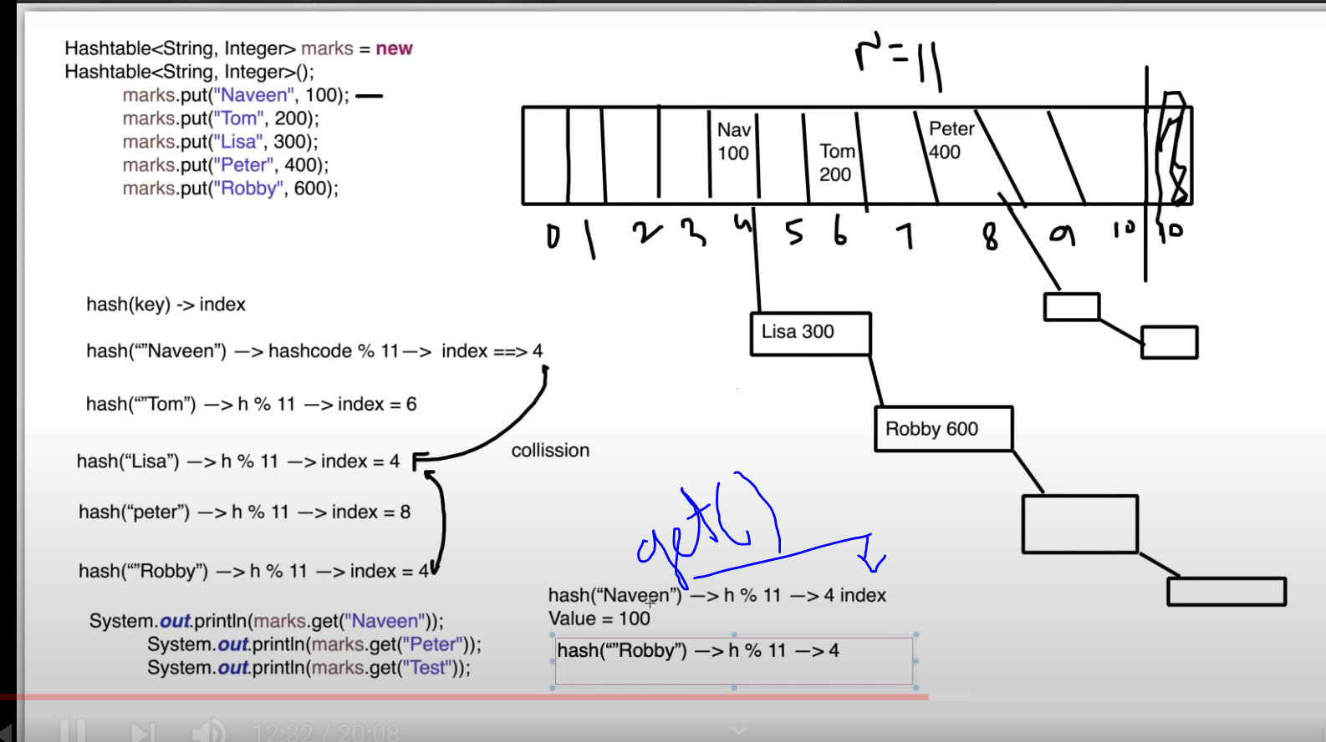

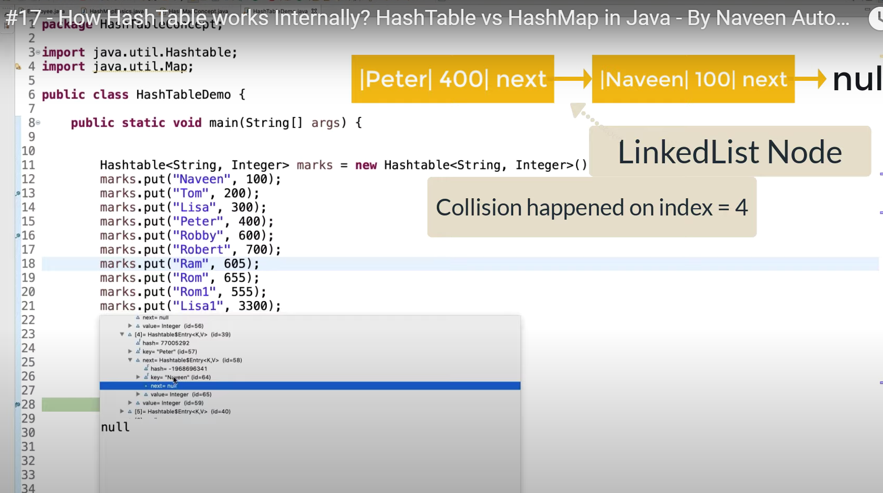

**Linked hashmap:**

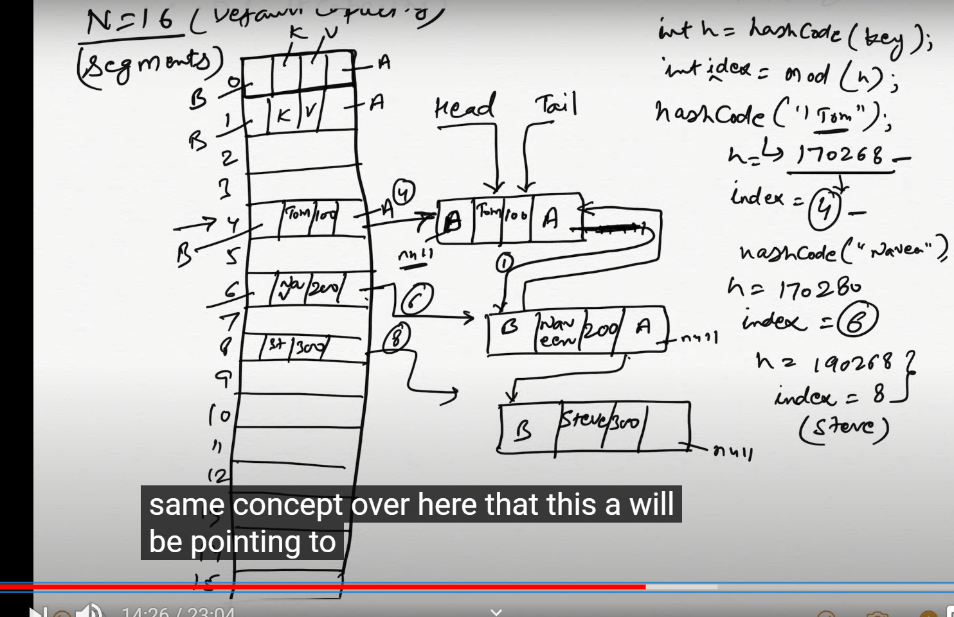

**Get(key)- for getting value**

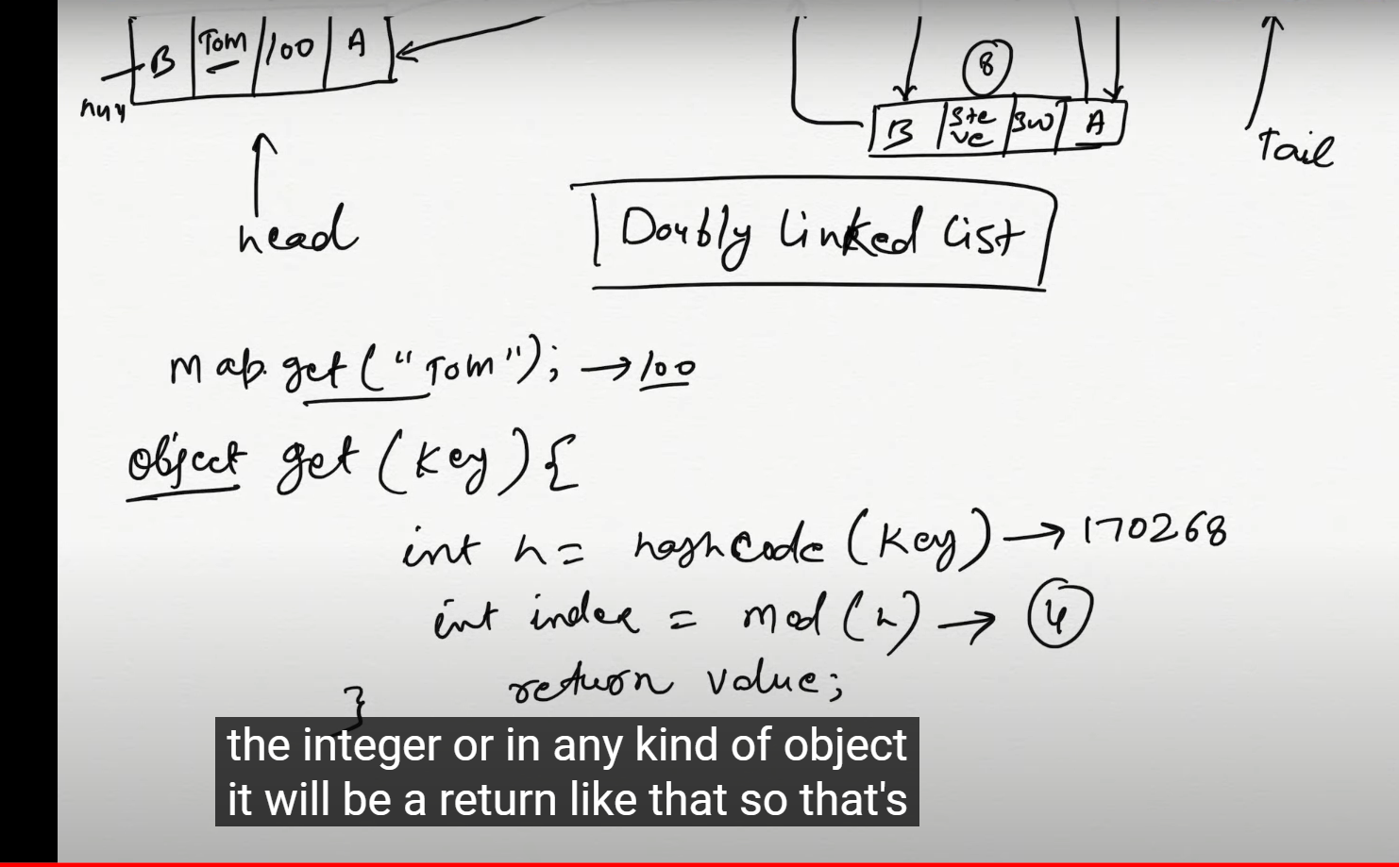

**Interface- Queue**

**• Queue Interface is a sub interface of Collection framework and Collection Interface**

**• It orders the elements in First in and First Out manner (FIFO)**

**• Queue interface is used in Digistra algorithm E.g. Google Maps**

**Declaration public Interface Queue<E> extends Collection<E>**

**Methods**

**Object remove() Retrieves and remove head element in queue**

**If Queue is empty, this method returns NoSuchElementException**

**Object poll() Retrieves and remove head of the queue**

**If Queue is empty, this method returns Null value**

**Object element() Retrieves, but does not remove the head of the Queue**

**If Queue is empty, this method returns NoSuchElementException**

**Object peek() Retrieves, but does not remove the head of the Queue**

**If Queue is empty, this method returns Null valueCore Java part 2**

**PriorityQueue - class**

**• PriorityQueue is an implementation Class of Queue Interface**

**• PriorityQueue does not support insertion order, Null values, duplicate values**

**• PriorityQueue throws NullPointerException**